<https://www.youtube.com/watch?v=7VeUPuFGJHk&list=PLblh5JKOoLUICTaGLRoHQDuF_7q2GfuJF&index=38>



Today we're gonna be talking about decision trees.

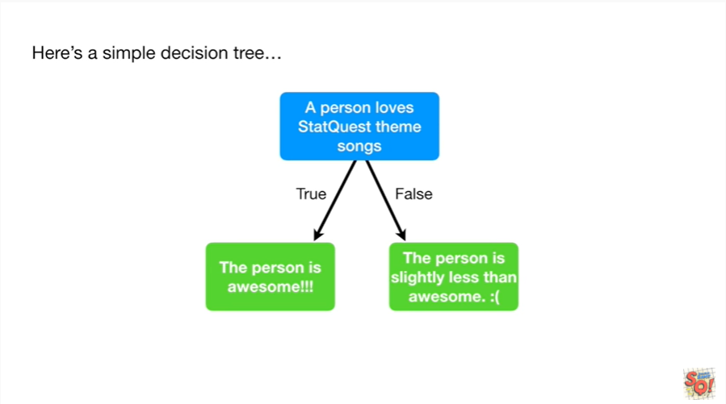

Here's a simple decision tree.

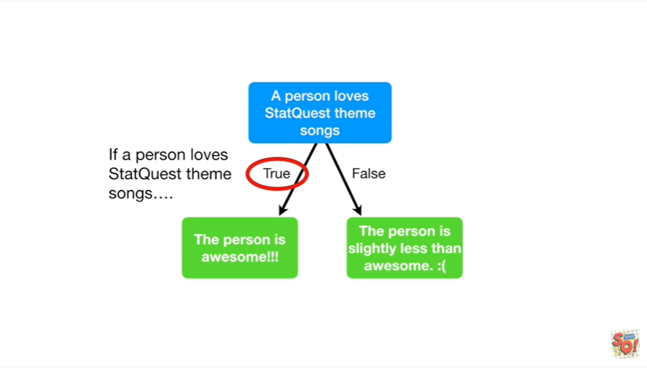

If a person loves stat quest theme songs

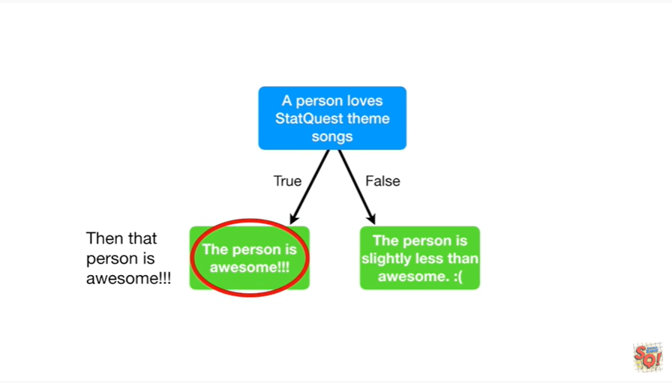

then that person is awesome.

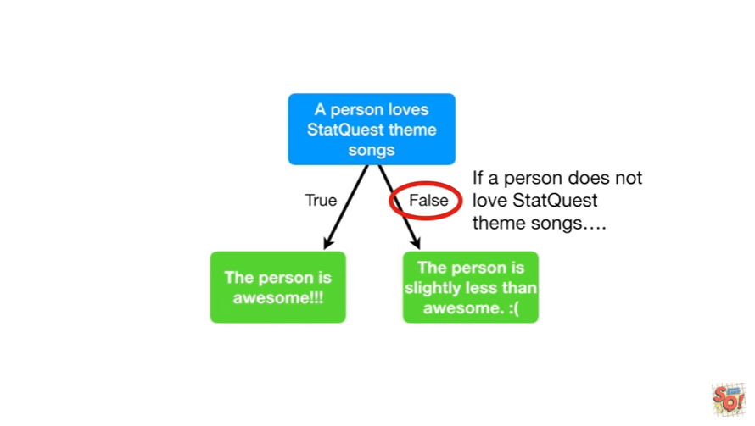

And if a person does not love stat quest theme songs

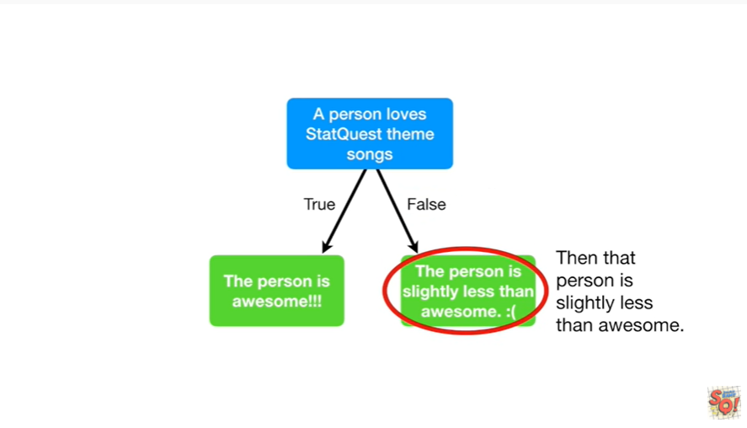

then that person is slightly less than awesome.

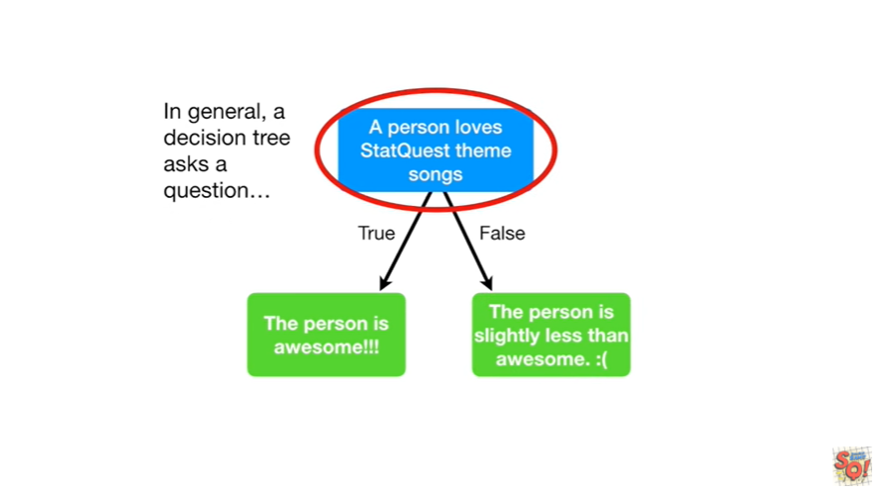

In general a decision tree asks a question

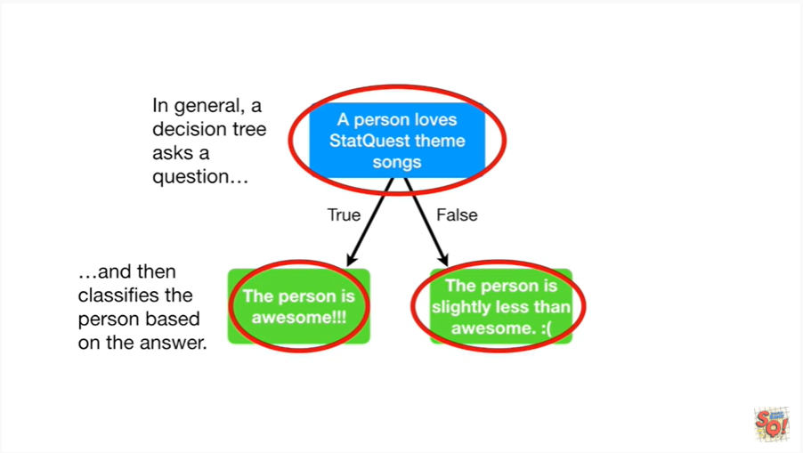

and then classifies the person based on the answer.

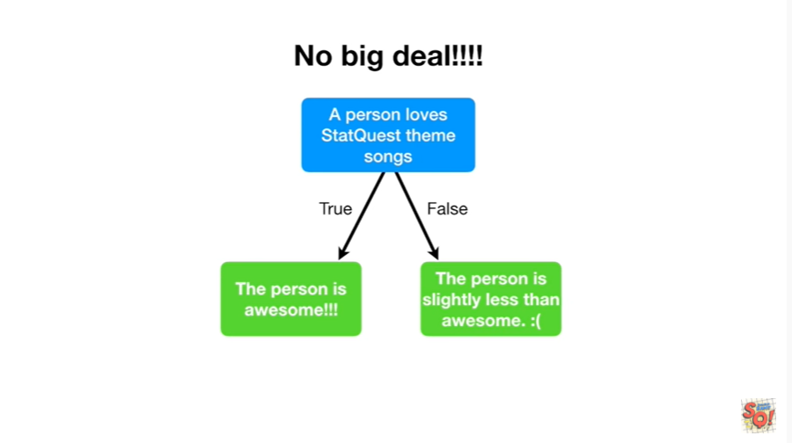

It's no big deal !!!!

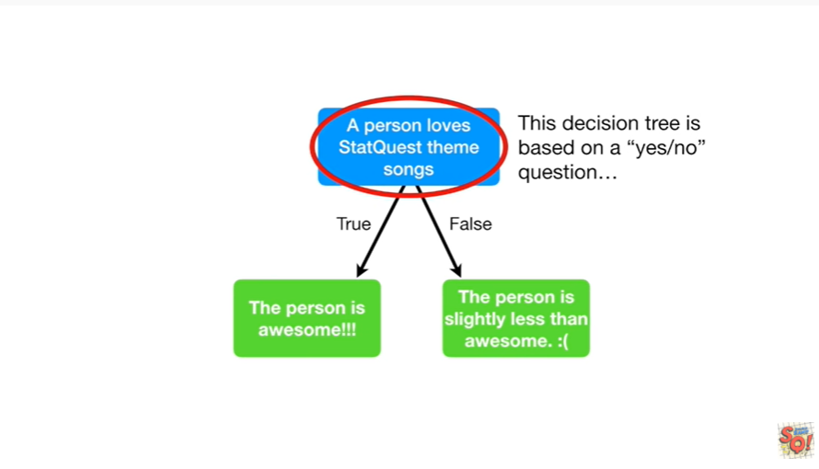

This decision tree is based on a yes/no question

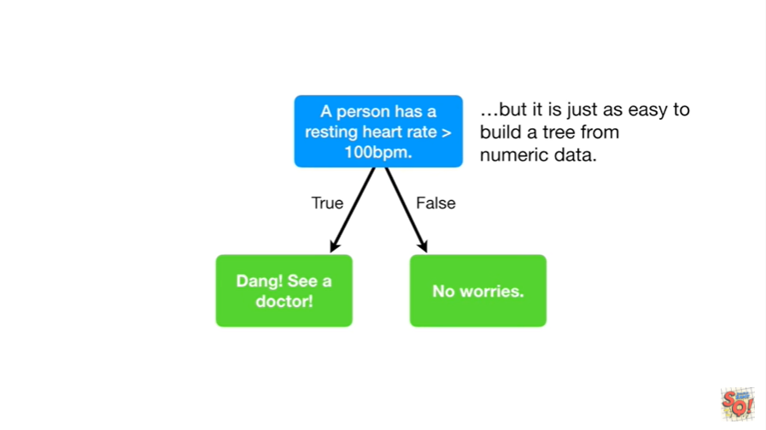

but it is just as easy to build a tree from numeric data.

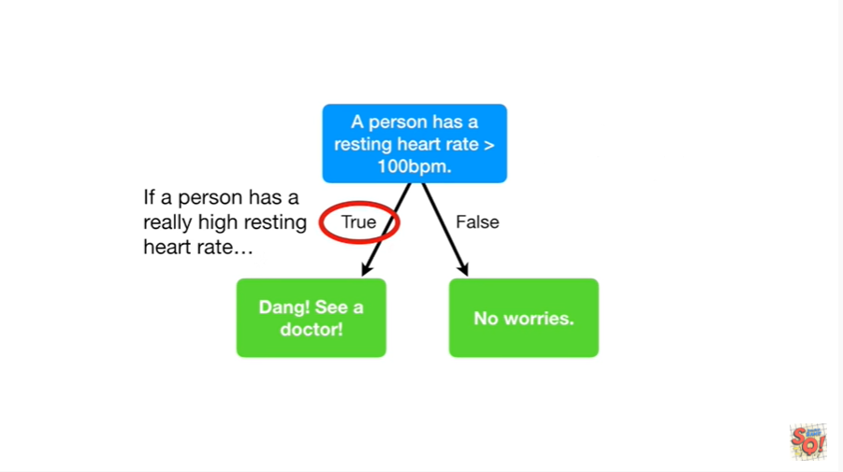

If a person has a really high resting heart rate

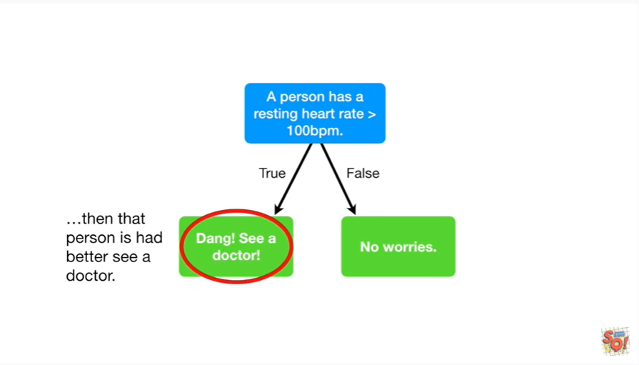

then that person had better see a doctor.

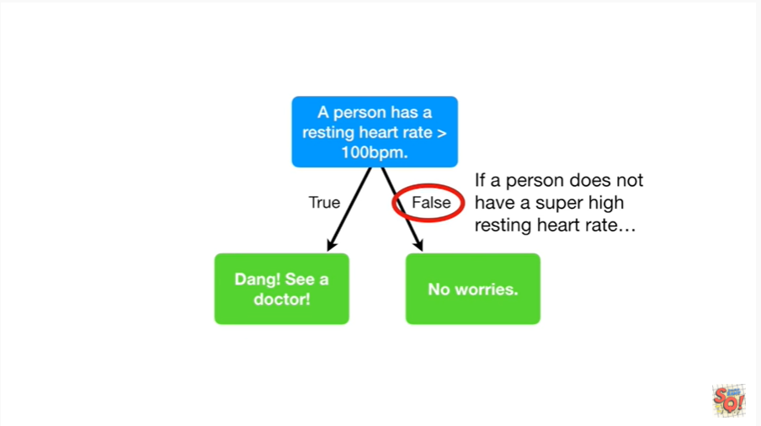

And if a person does not have a super high resting heart rate

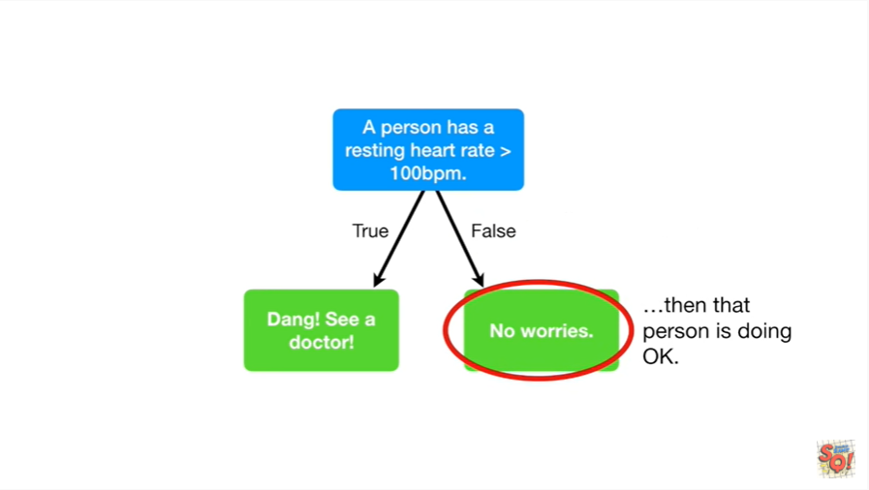

then that person is doing okay.

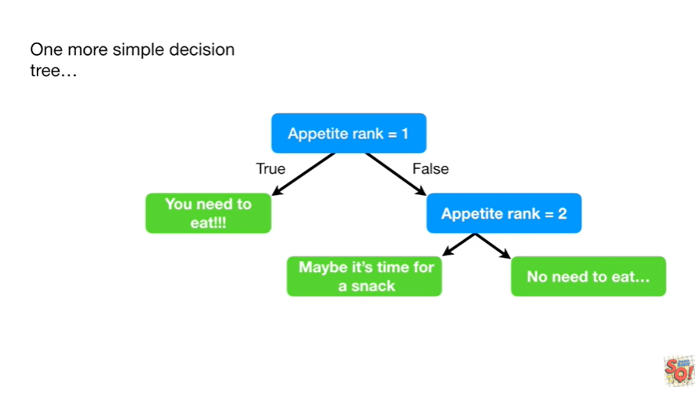

Here's one more simple decision tree.

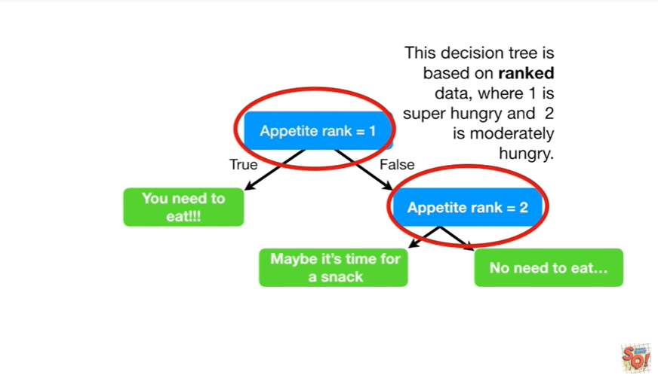

This decision tree is based on ranked data where one is super hungry and two is moderately hungry.

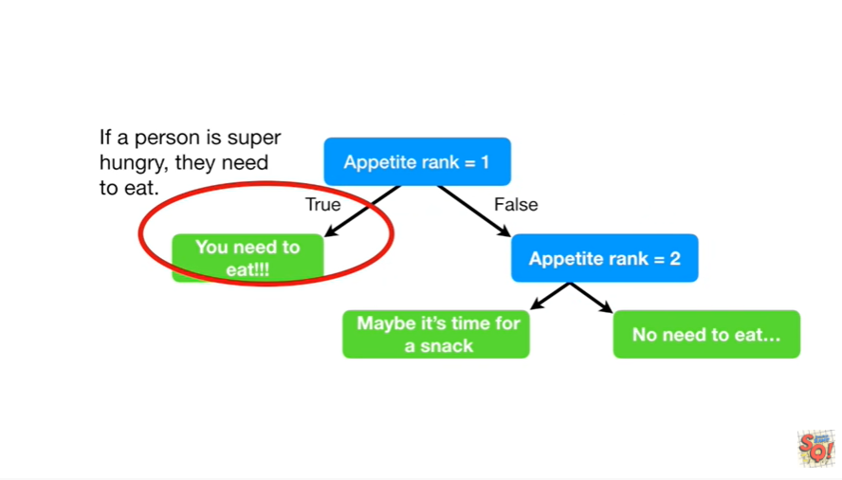

If a person is super hungry they need to eat.

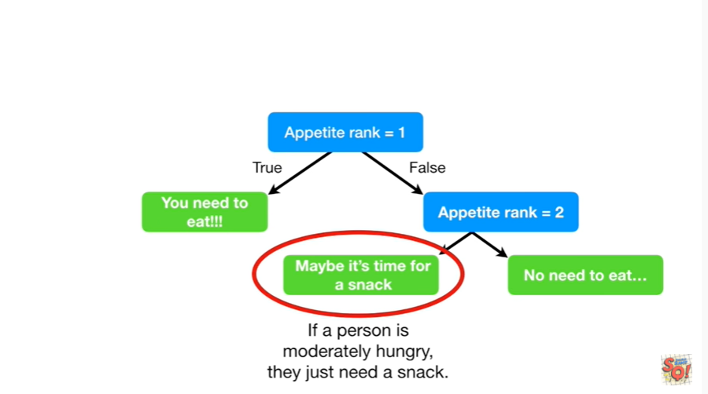

And if a person is moderately hungry they just need a snack.

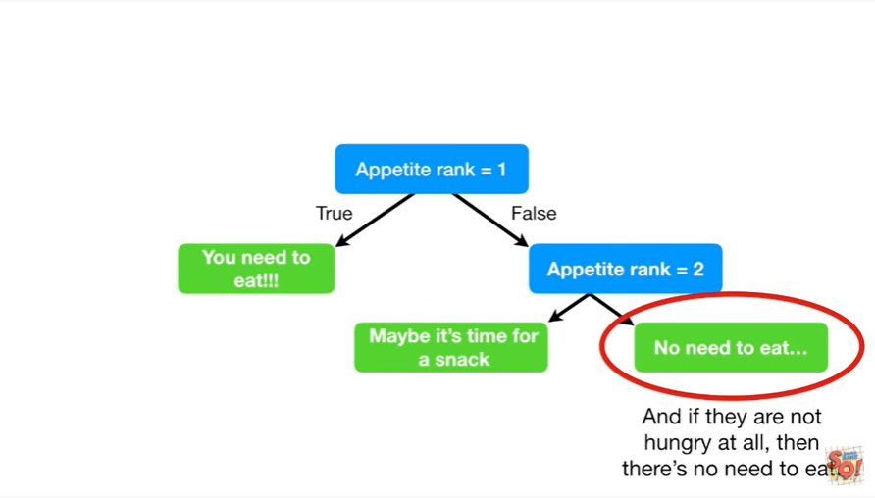

And if they are not hungry at all, then there's no need to eat.

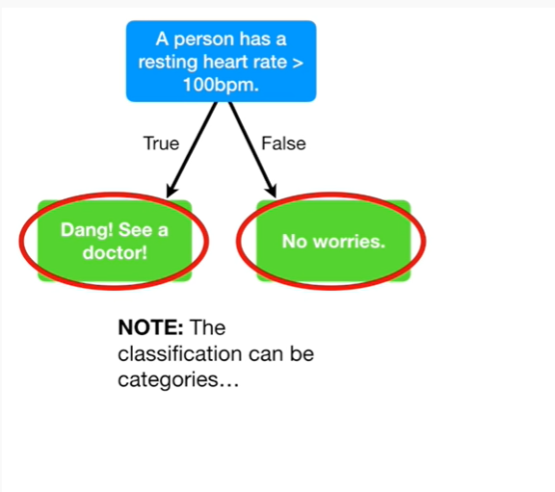

Note : the classification can be categories

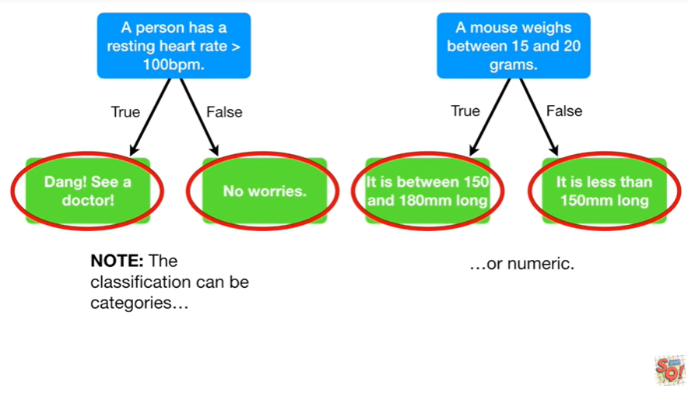

or numeric.

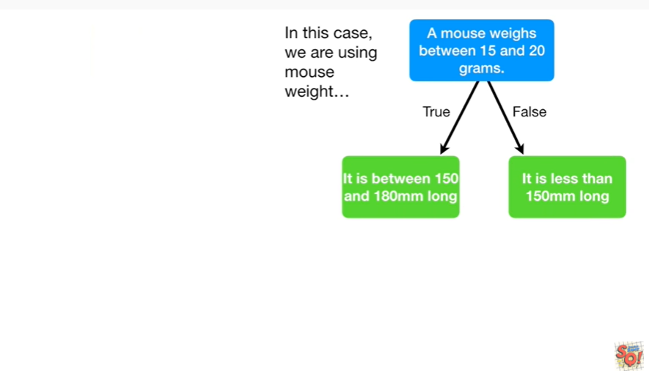

In this case we're using Mouse weight

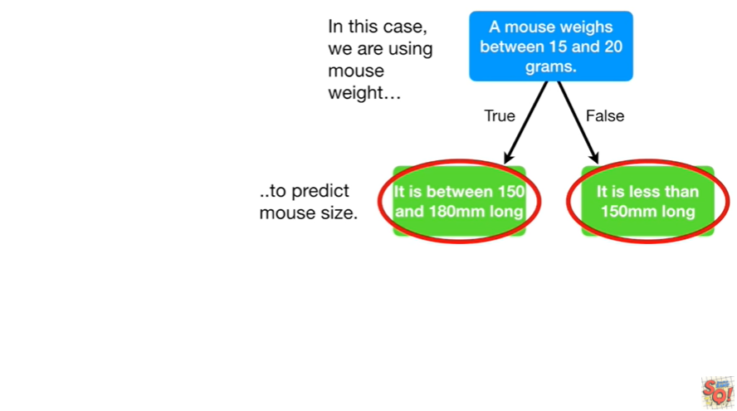

to predict Mouse size.

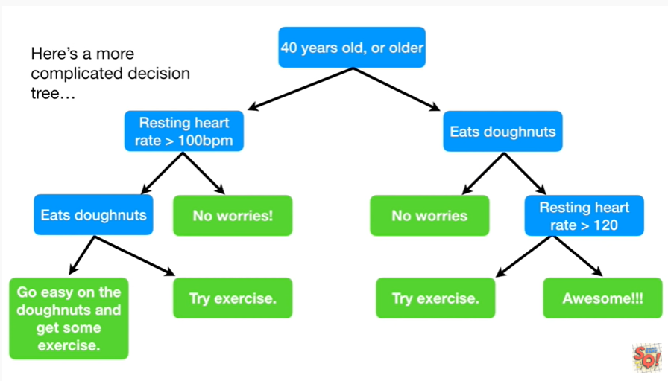

Here's a more complicated decision tree.

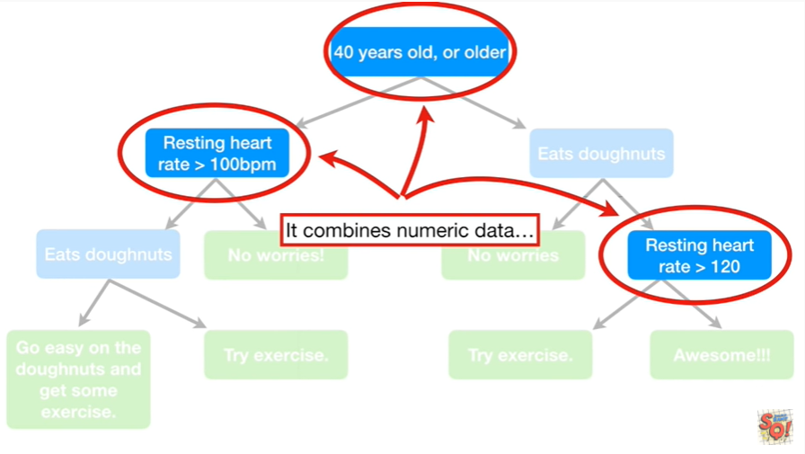

It combines numeric data

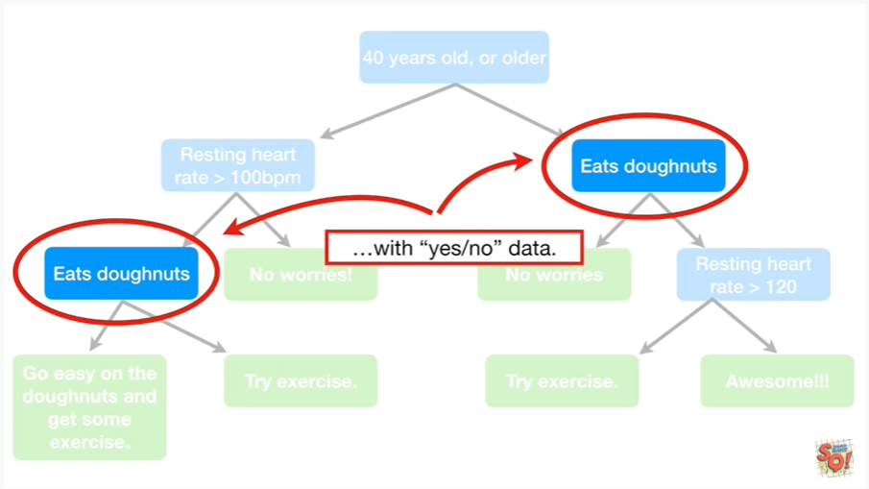

with yes/no data.

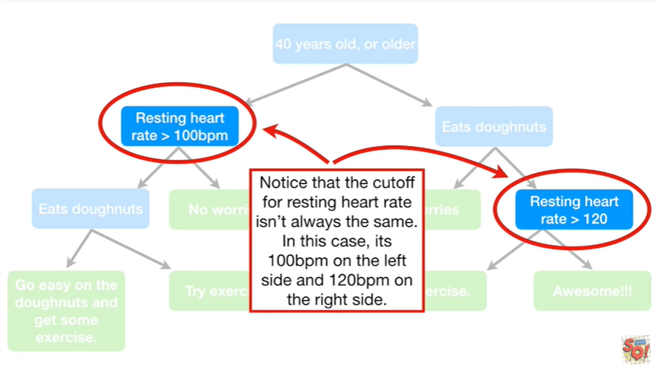

Notice that the cutoff for resting heart rate isn't always the same.

In this case is a hundred BPM on the left side and a hundred and twenty BPM on the right side.

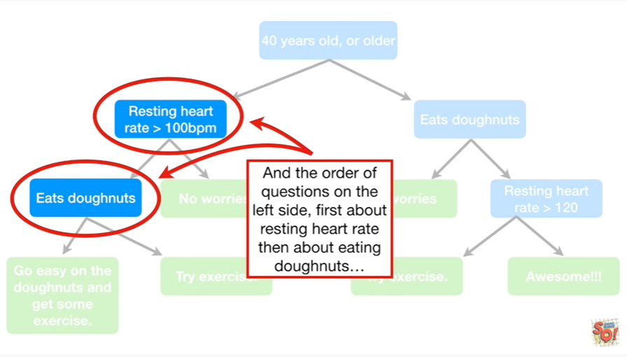

And the order of questions on the left side first about resting heart rate then about eating donuts

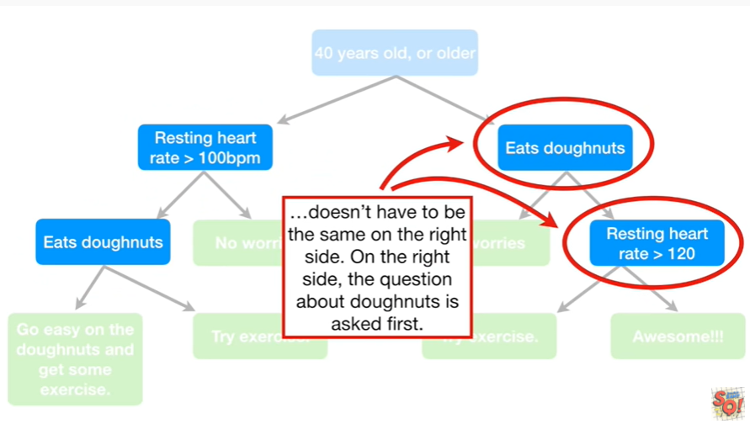

doesn't have to be the same on the right side.

On the right side the question about donuts is asked first.

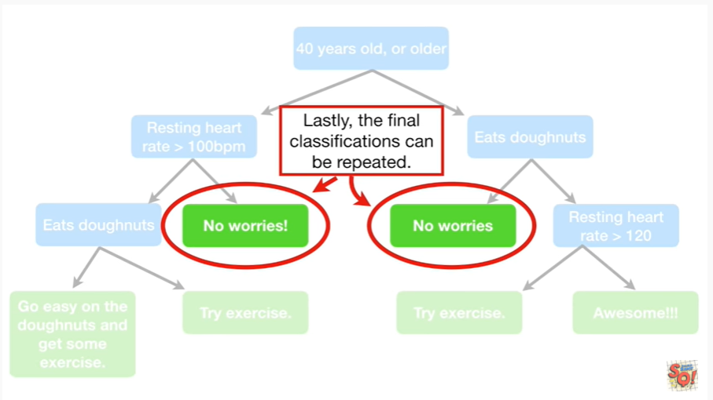

Lastly, the final classifications can be repeated.

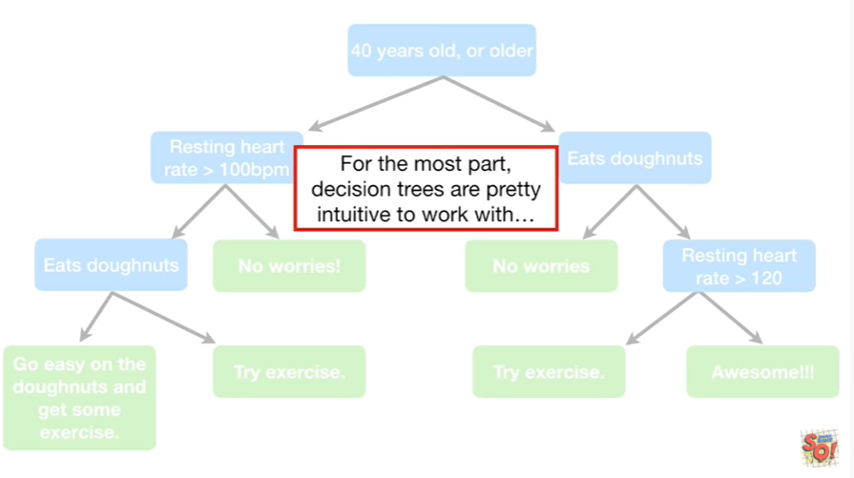

For the most part decision trees are pretty intuitive to work with.

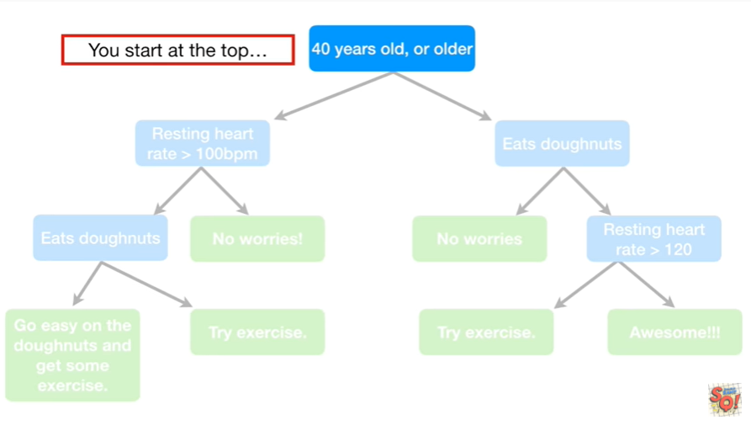

You start at the top

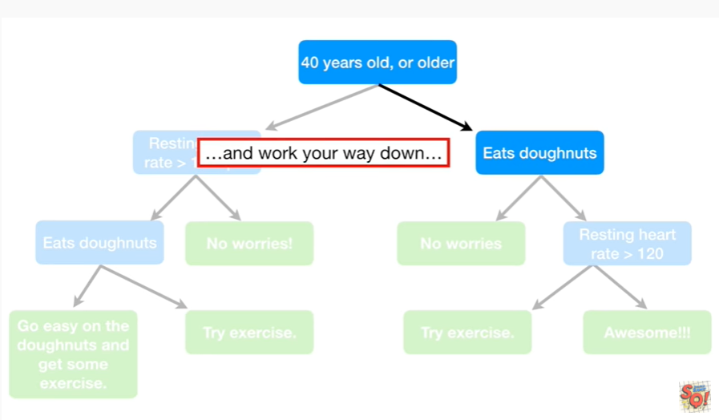

and work your way down

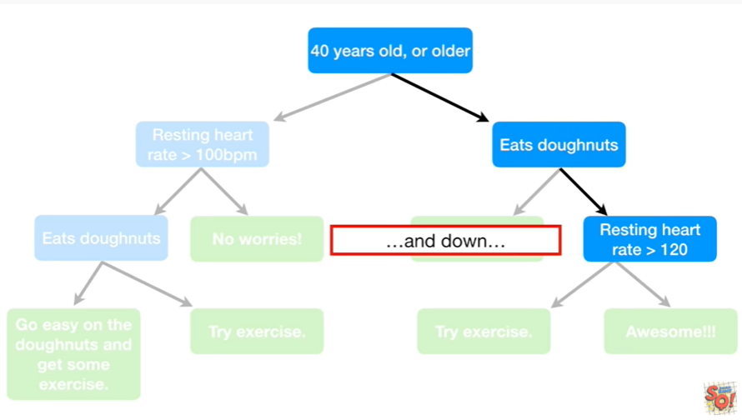

and down

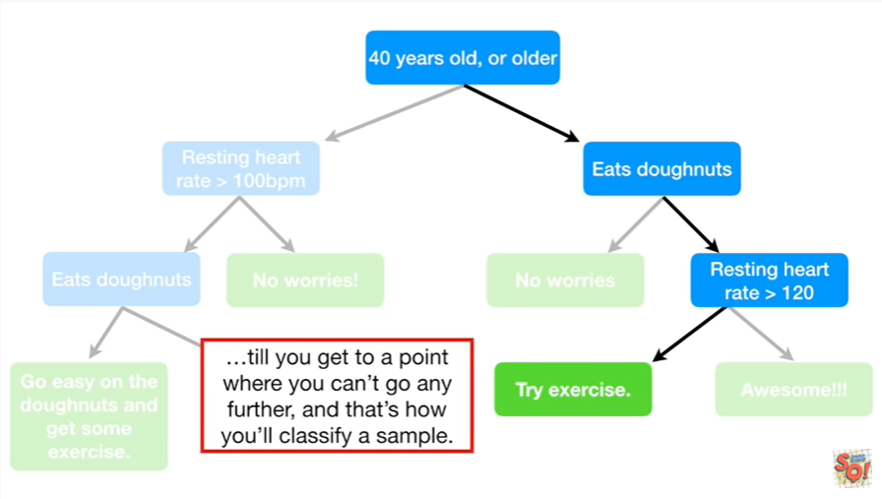

till you get to a point where you can't go any further, and that's how you classify a sample.



Oh no jargon alert !!!

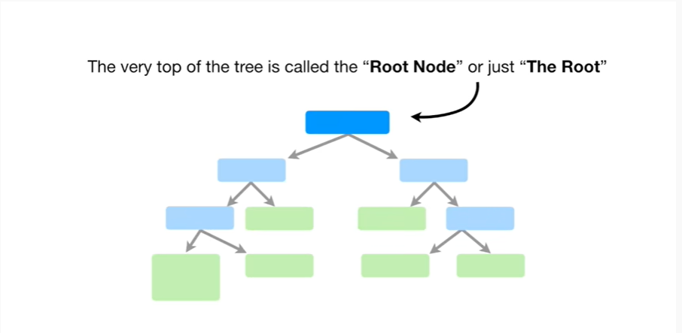

The very top of the tree is called the root node or just the root.

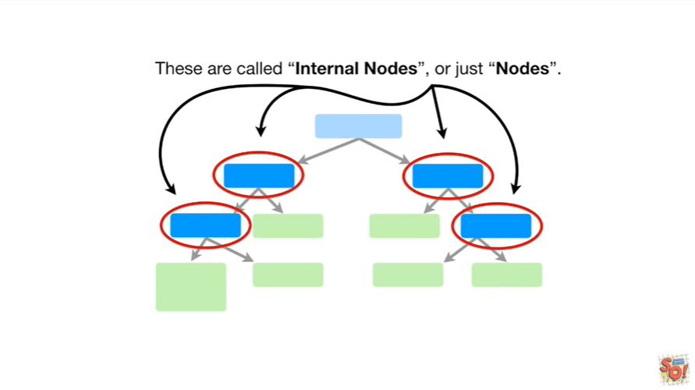

These are called internal nodes or just nodes.

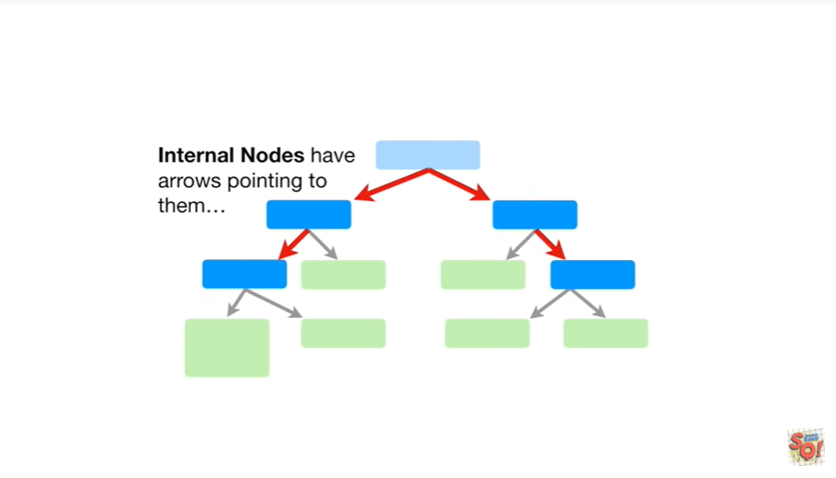

Internal nodes have arrows pointing to them

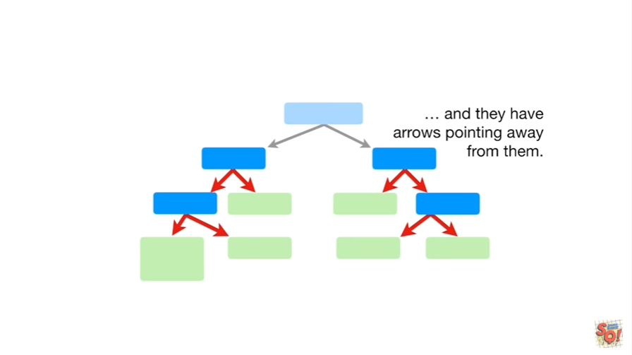

and they have arrows pointing away from them.

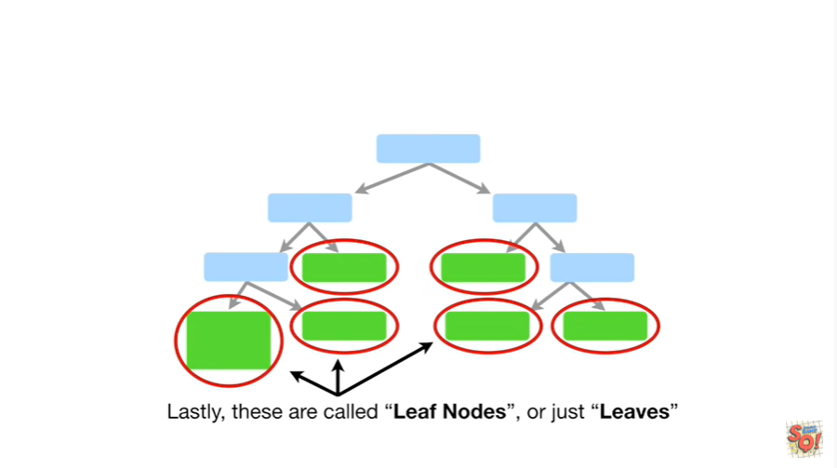

Lastly, these are called leaf nodes, or just leaves.

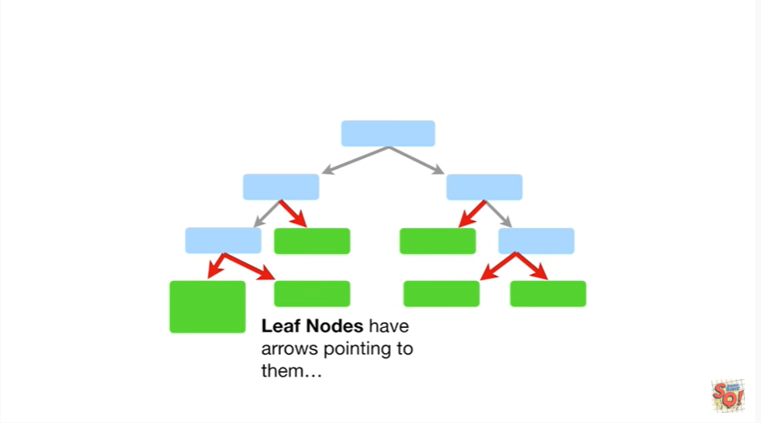

Leaf nodes have arrows pointing to them

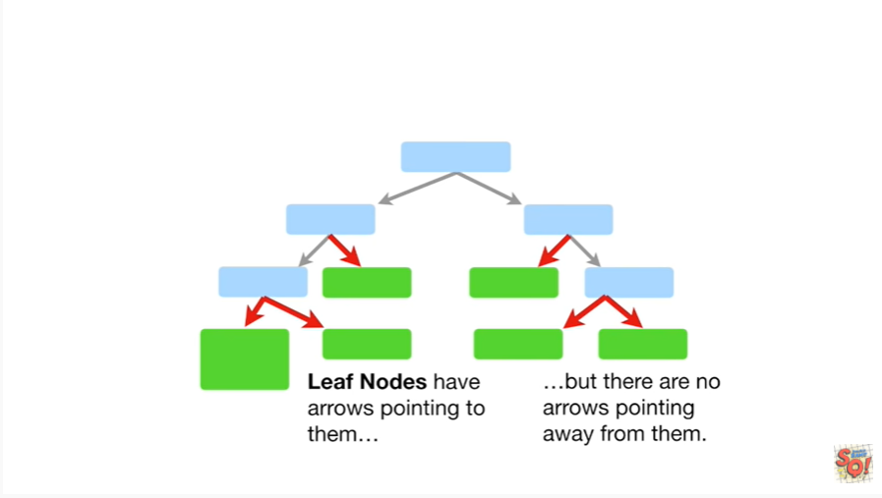

but there are no arrows pointing away from them.

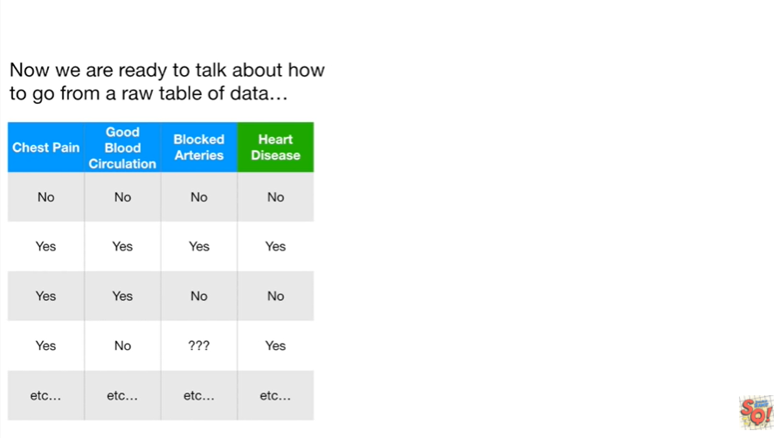

Now we are ready to talk about how to go from a raw table of data

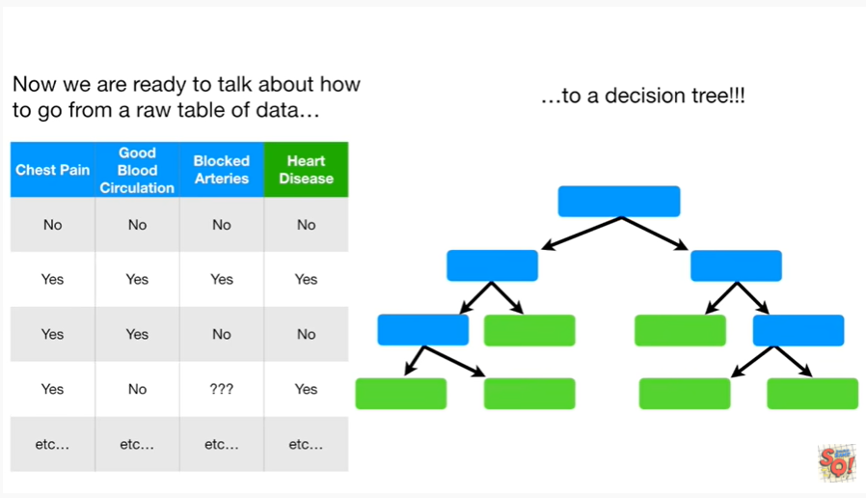

to a decision tree.

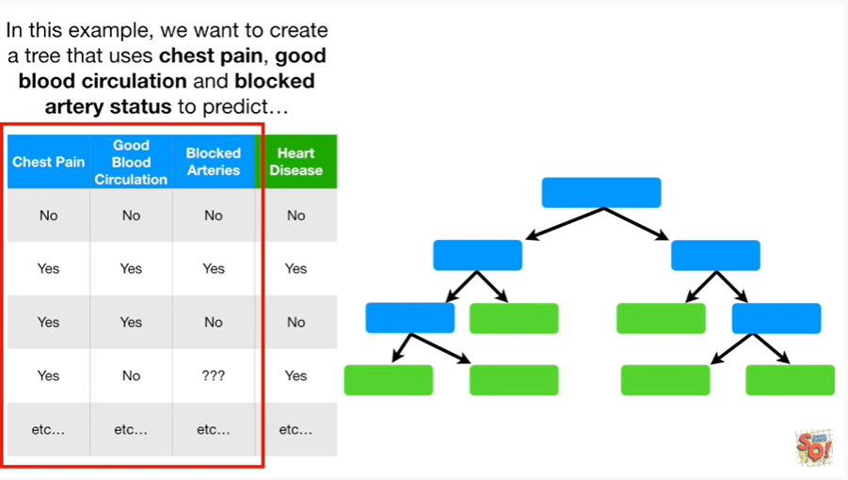

In this example we want to create a tree that uses chest pain, good blood circulation and blocked artery status to predict

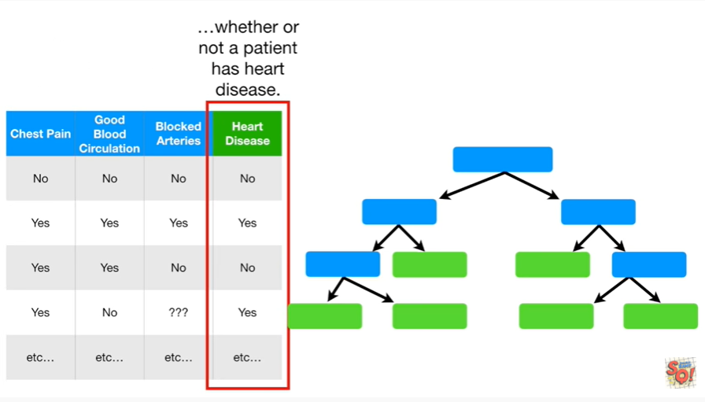

whether or not a patient has heart disease.

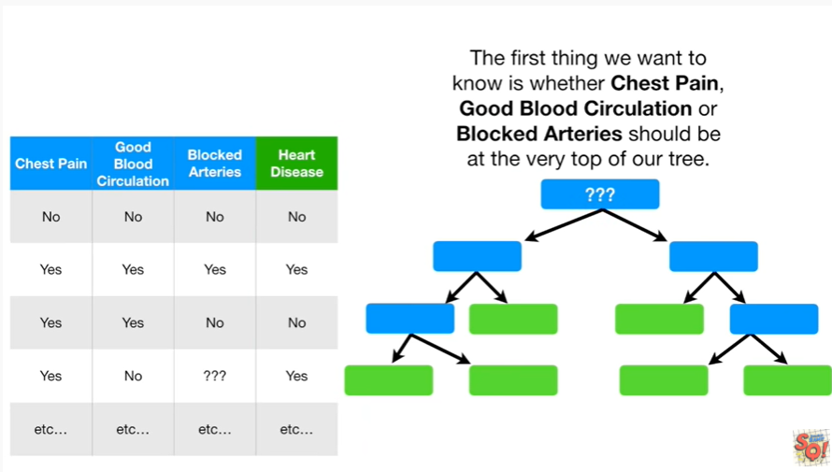

The first thing we want to know is whether chest pain, good blood circulation or blocked arteries should be at the very top of our tree.

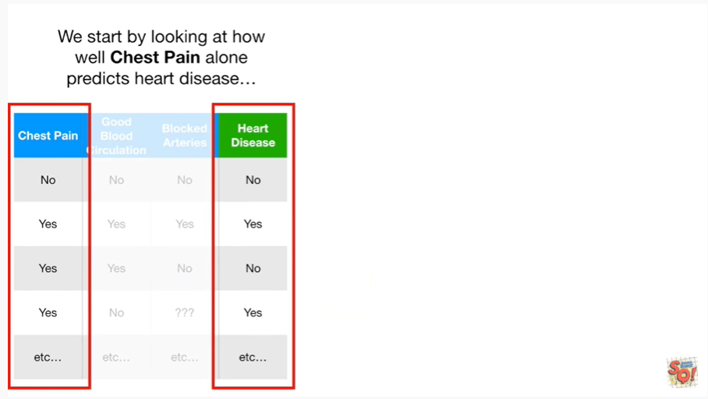

We start by looking at how well chest pain alone predicts heart disease.

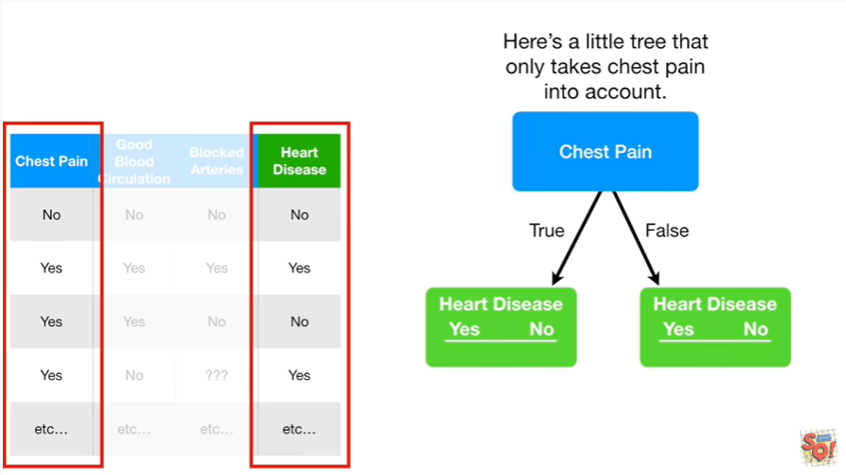

Here's a little tree that only takes chest pain into account.

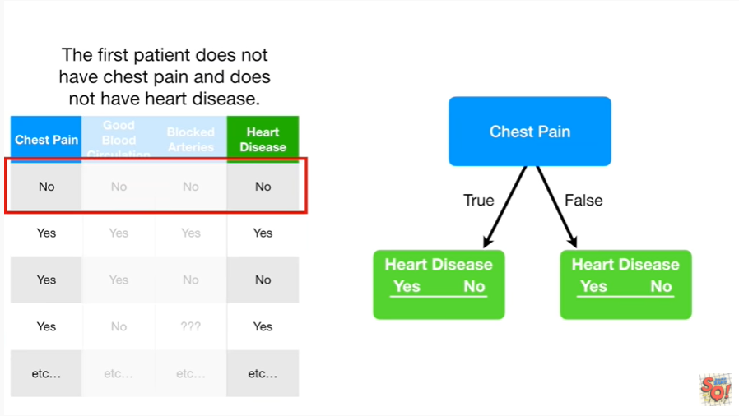

The first patient does not have chest pain and does not have heart disease

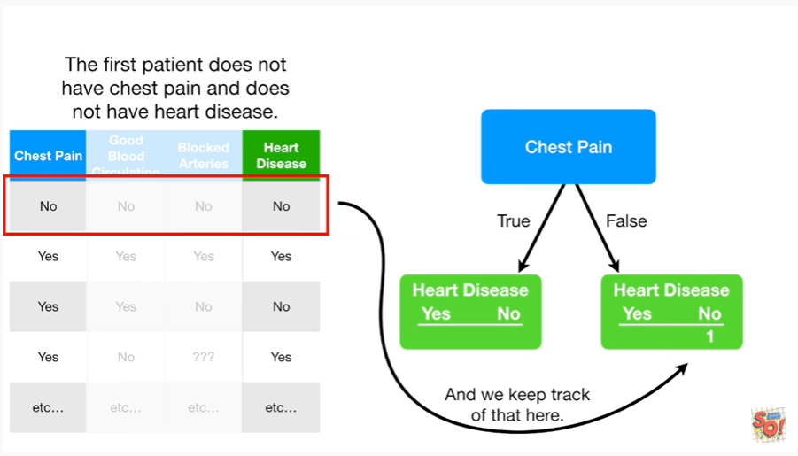

and we keep track of that here.

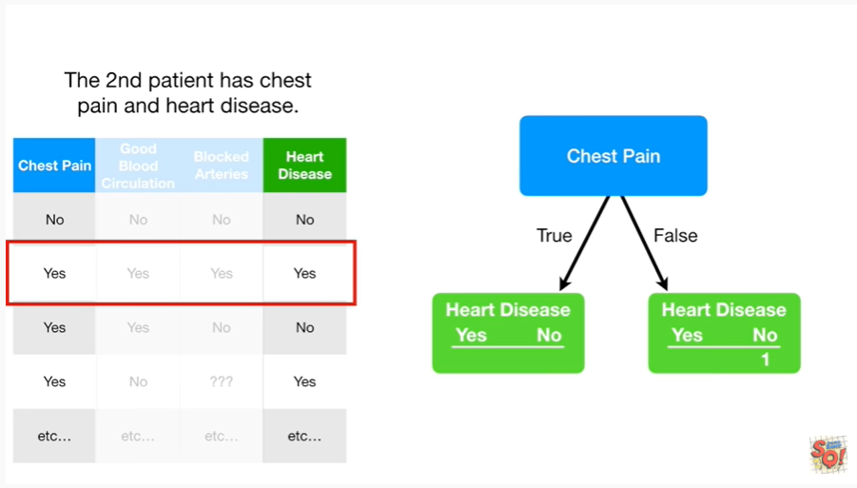

The second patient has chest pain and heart disease

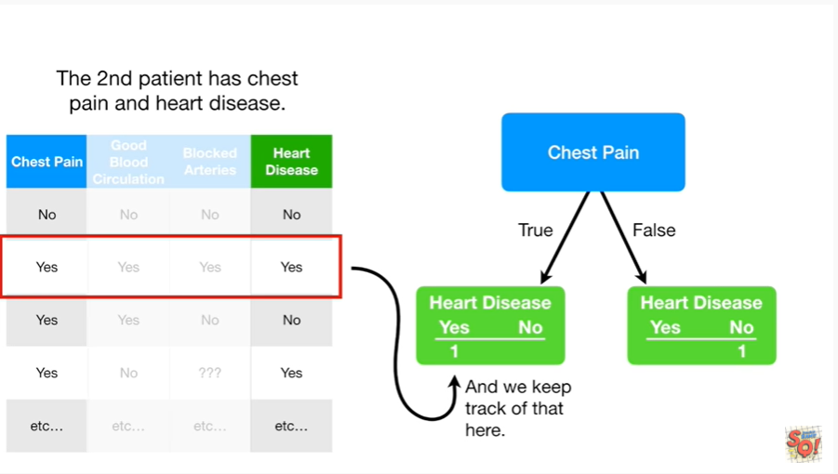

and we keep track of that here.

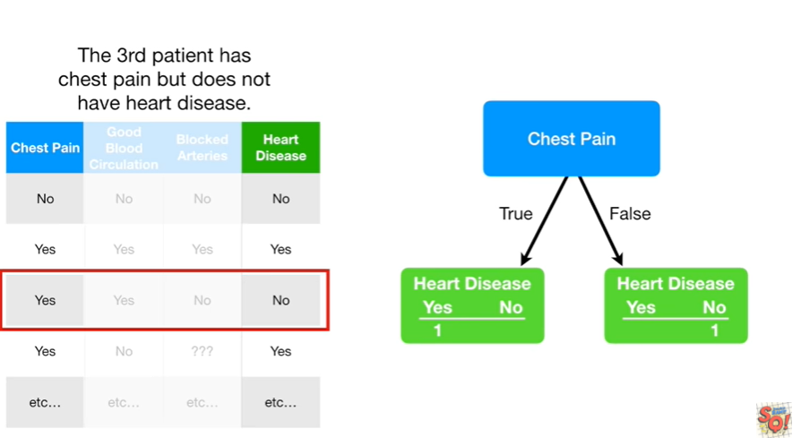

The third patient has chest pain but does not have heart disease.

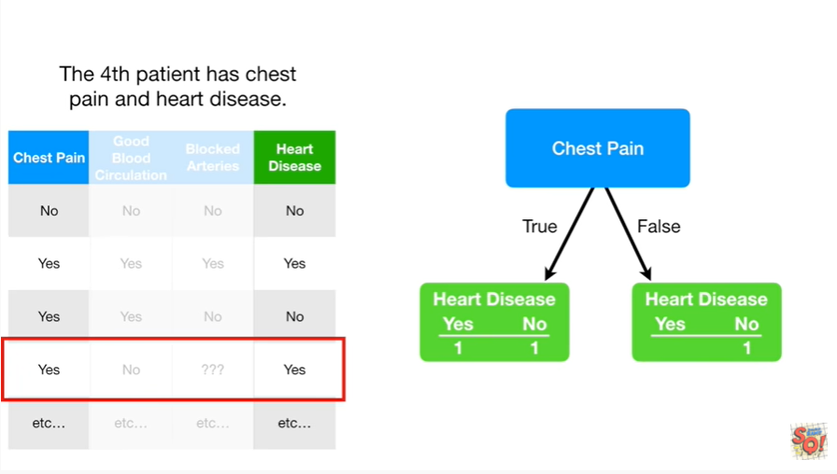

The fourth patient has chest pain and heart disease.

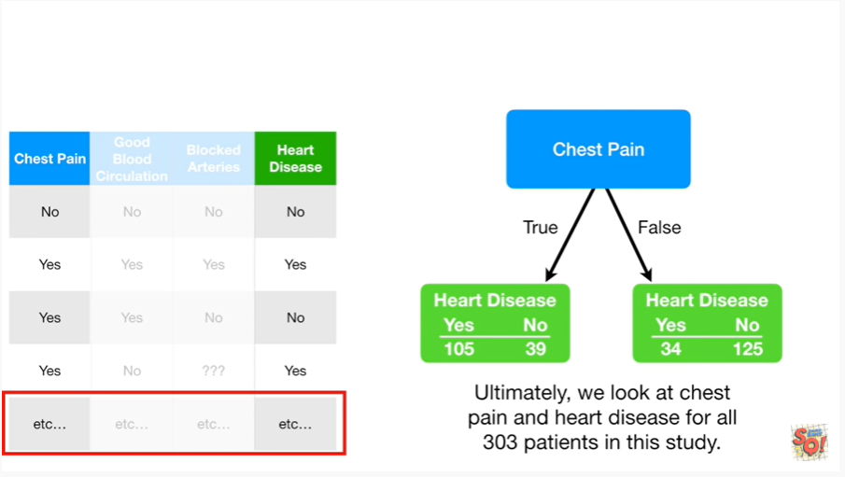

Ultimately we look at chest pain and heart disease for all 303 patients in this study.

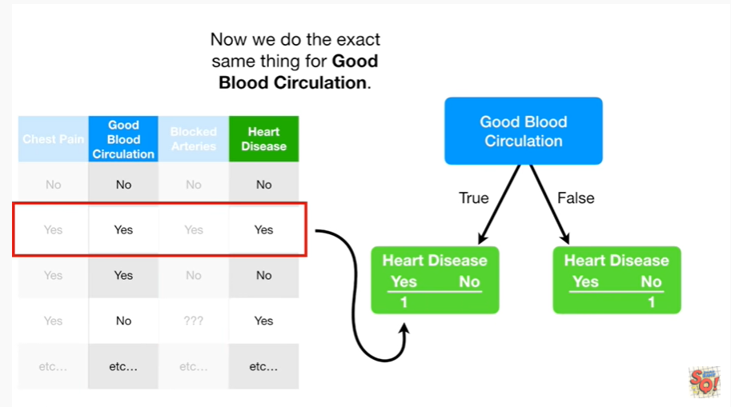

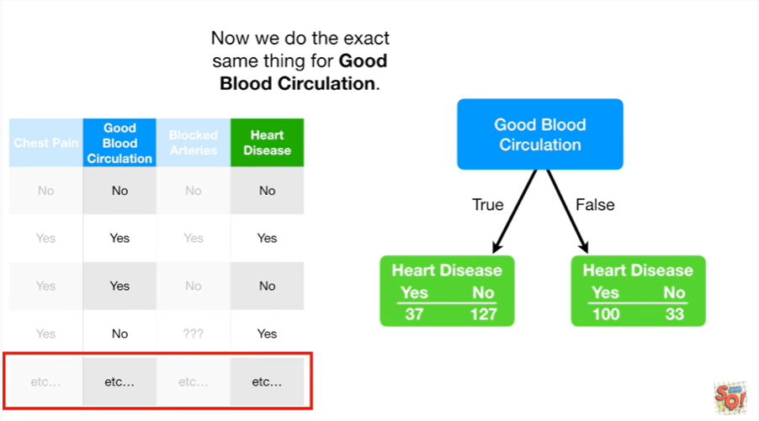

Now we do the exact same thing for good blood circulation.

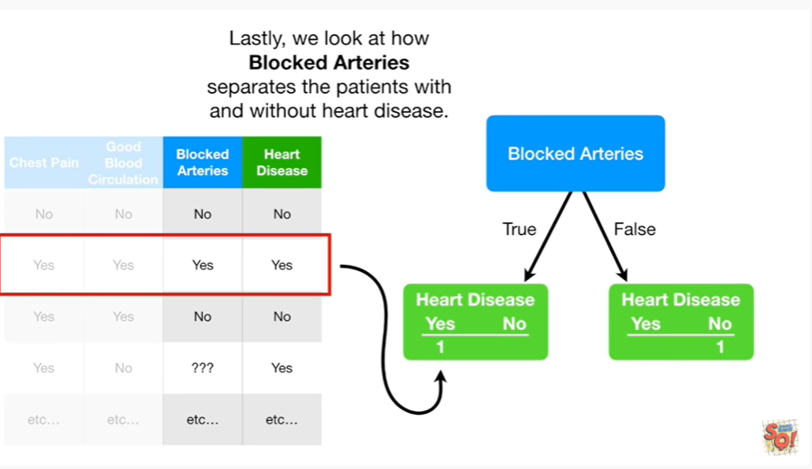

Lastly we look at how blocked arteries separates the patients with and without heart disease.

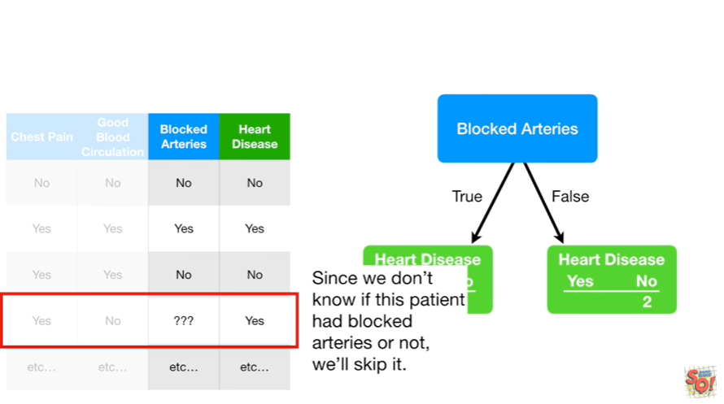

Since we don't know if this patient had blocked arteries or not we'll skip it.

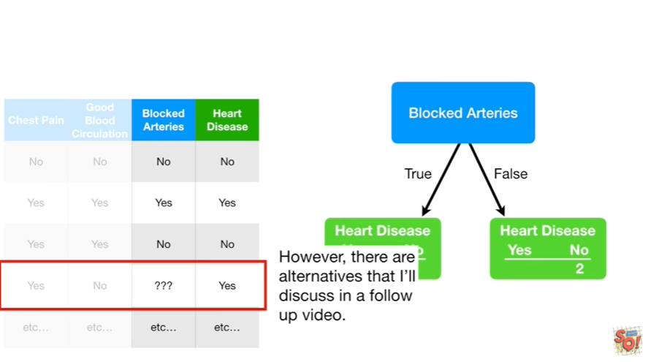

However there are alternatives that I'll discuss in a follow-up video.

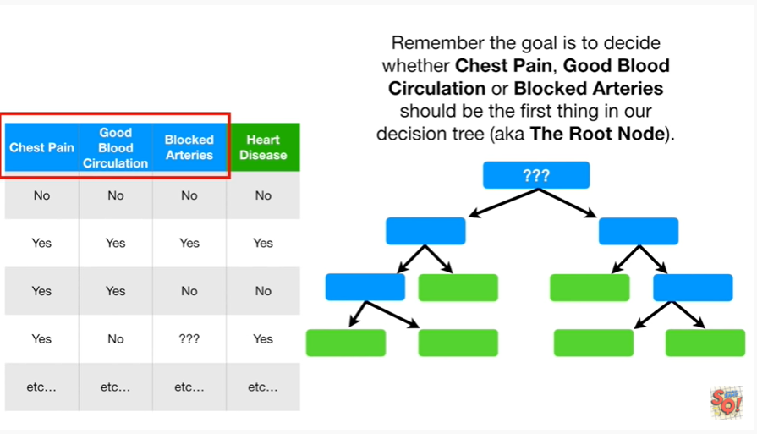

Remember the goal is to decide whether chest pain, good blood circulation or blocked arteries should be the first thing in our decision tree (aka the root node).

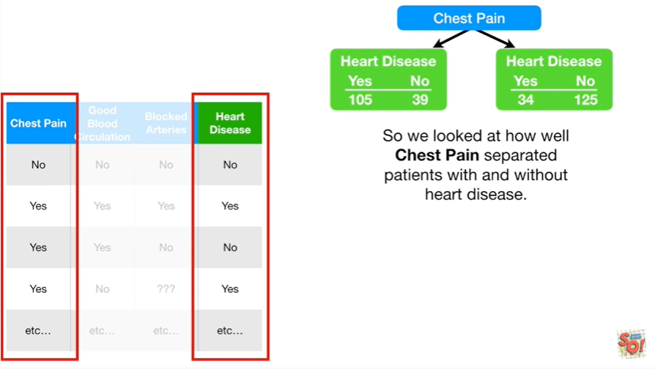

So we looked at how well chest pain separated patients with and without heart disease.

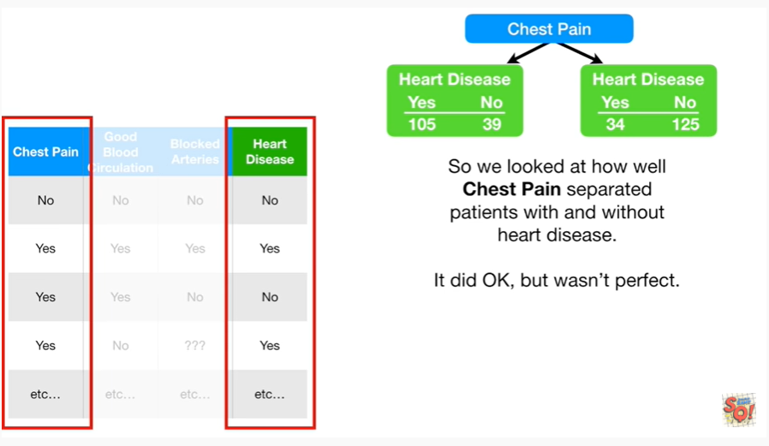

It did okay, but wasn't perfect.

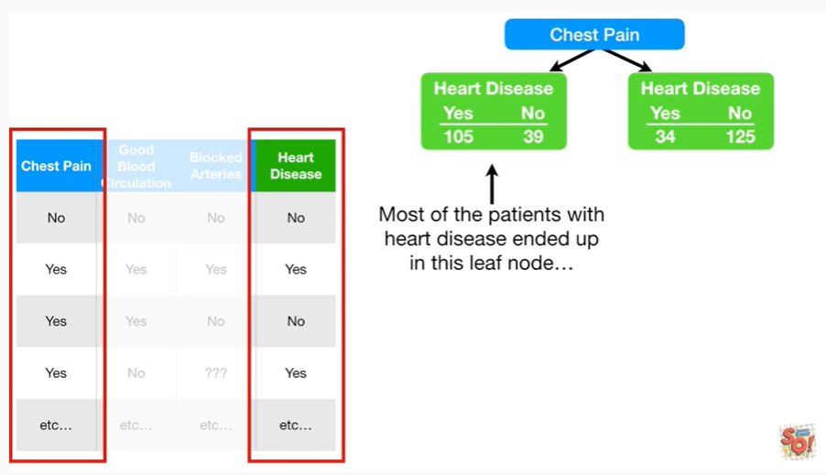

Most of the patients with heart disease ended up in this leaf node

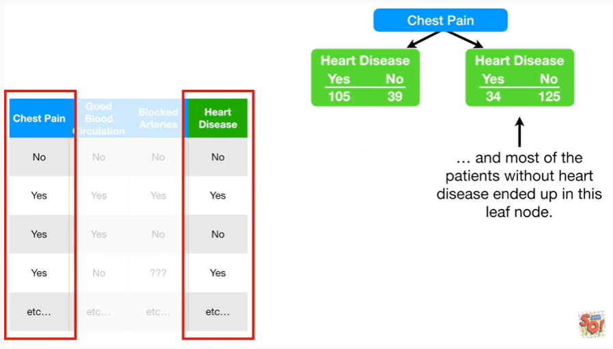

and most of the patients without heart disease ended up in this leaf node.

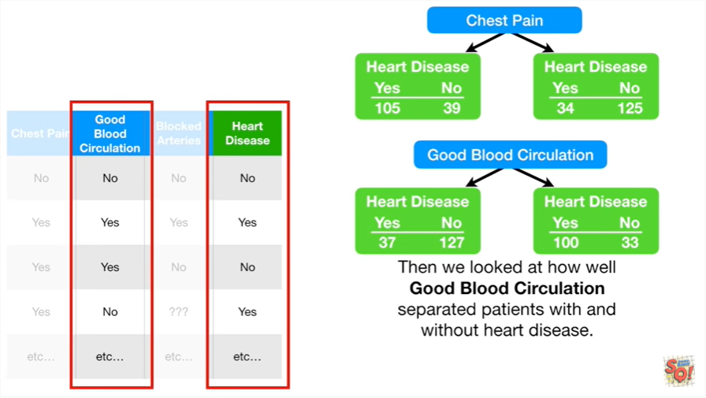

Then we looked at how well good blood circulation separated patients with and without heart disease.

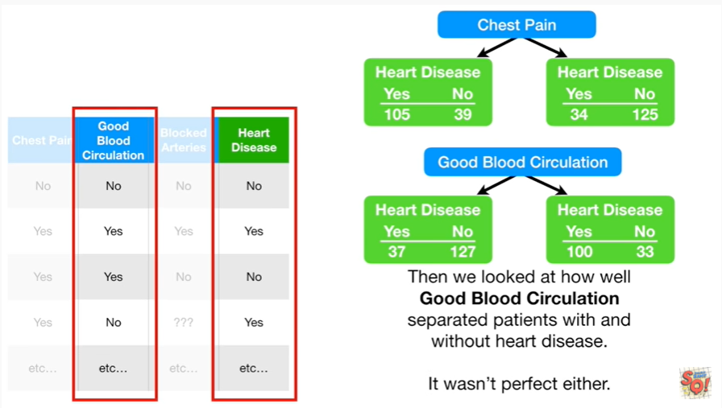

It wasn't perfect either.

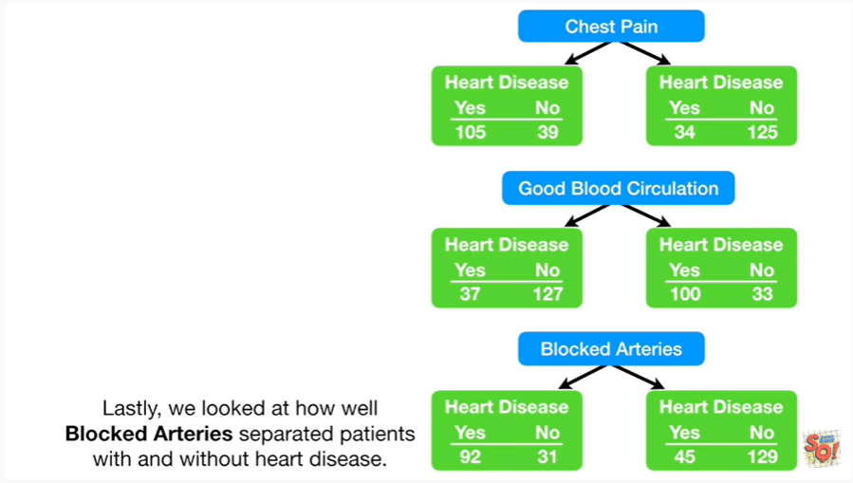

Lastly we looked at how well blocked arteries separated patients with and without heart disease.

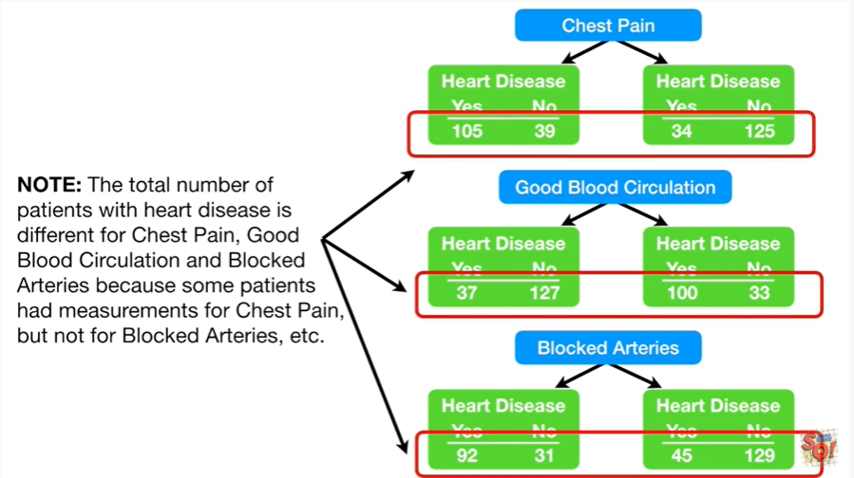

Note : the total number of patients with heart disease is different for chest pain, good blood circulation and blocked arteries because some patients had measurements for chest pain but not for blocked arteries, etc.

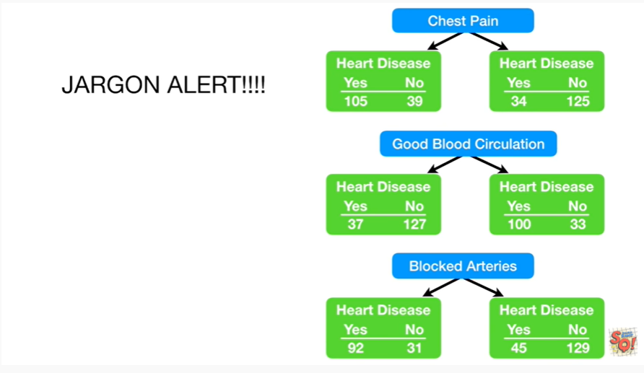

Oh no, it's another one of those ghastly jargon alerts.

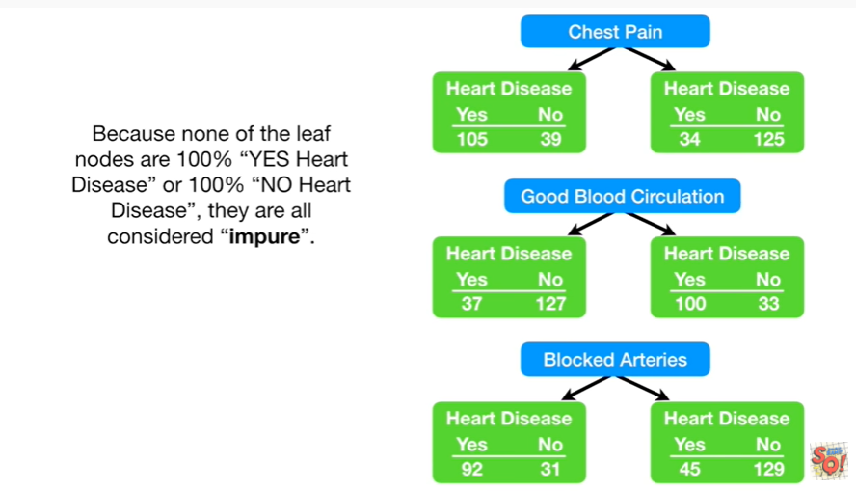

Because none of the leaf nodes are 100% yes heart disease or 100% no heart disease they are all considered impure.

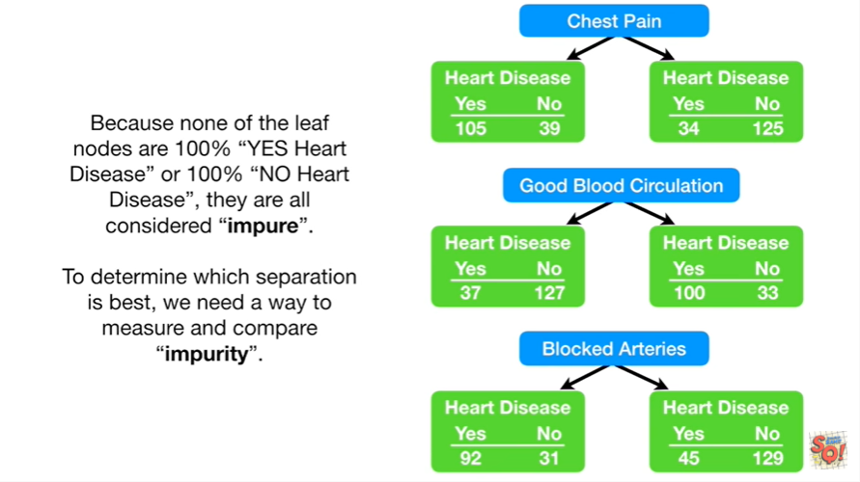

To determine which separation is best we need a way to measure and compare impurity.

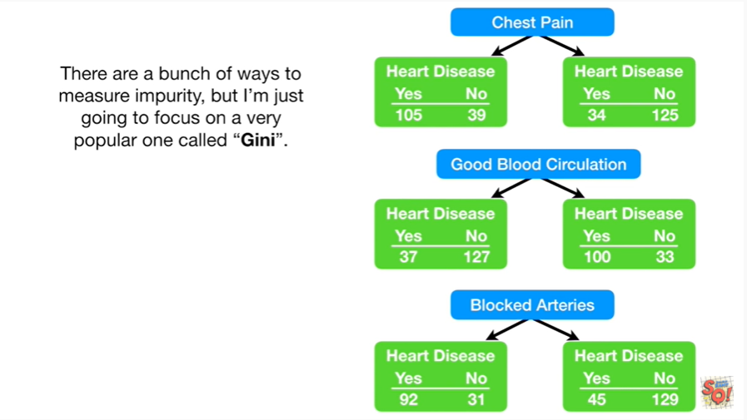

There are a bunch of ways to measure impurity but I'm just going to focus on a very popular one called ‘Gini’.

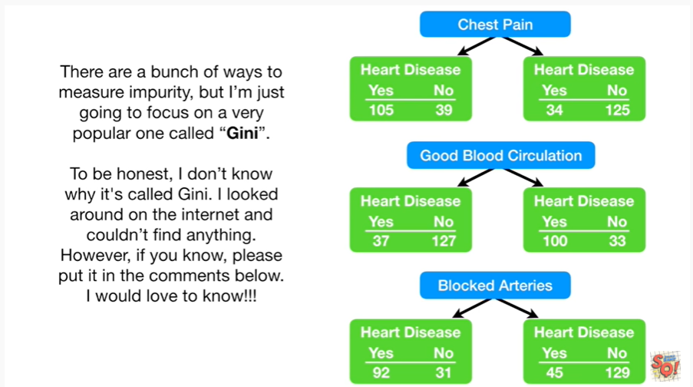

To be honest I don't know why it's called gini.

I looked around on the internet and couldn't find anything.

However, if you know, please put in the comments below.

I would love to know !!!

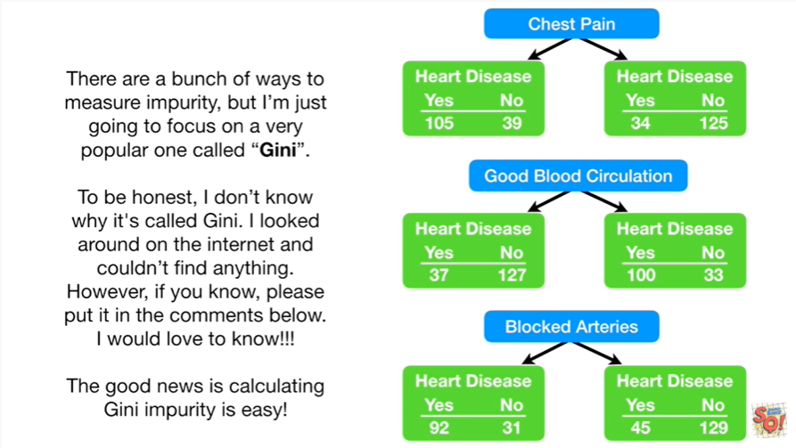

Regardless, the good news is calculating Gini impurity is easy.

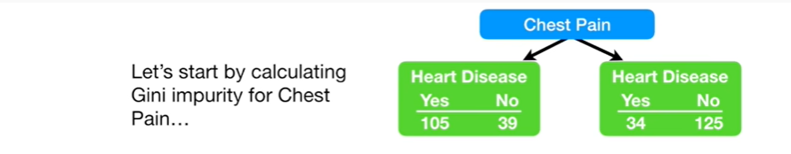

Let's start by calculating Gini impurity for chest pain.

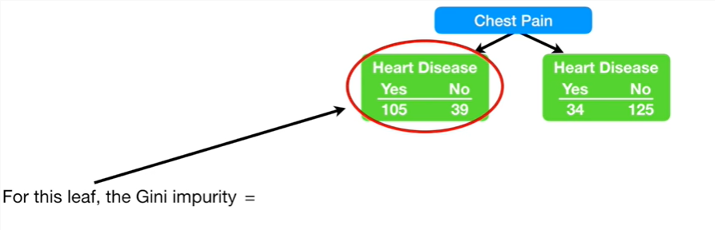

For this leaf the Gini impurity equals

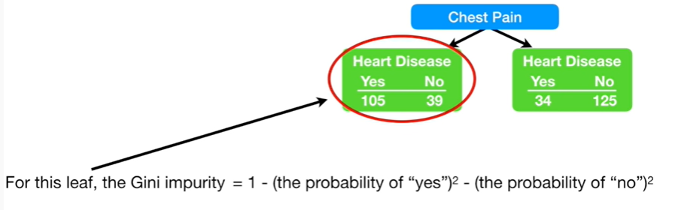

one minus the probability of yes squared minus the probability of no squared.

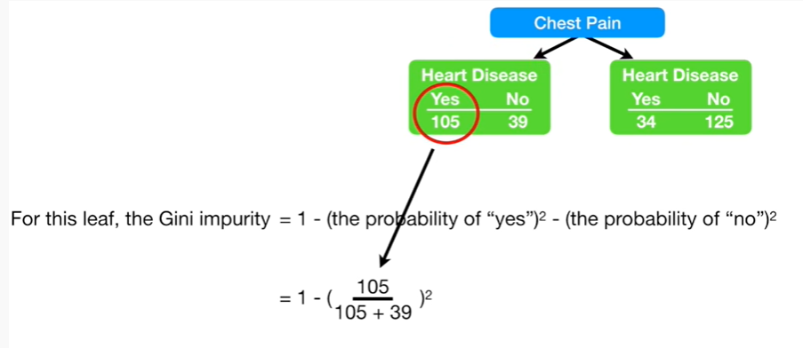

Now let's plug in some numbers :

the probability of yes equals 105 divided by the total number of people in this leaf node.

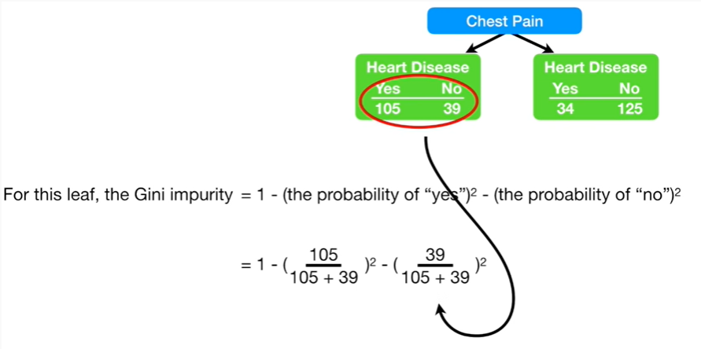

and the probability of no equals 39 divided by the total number of people in this leaf node.

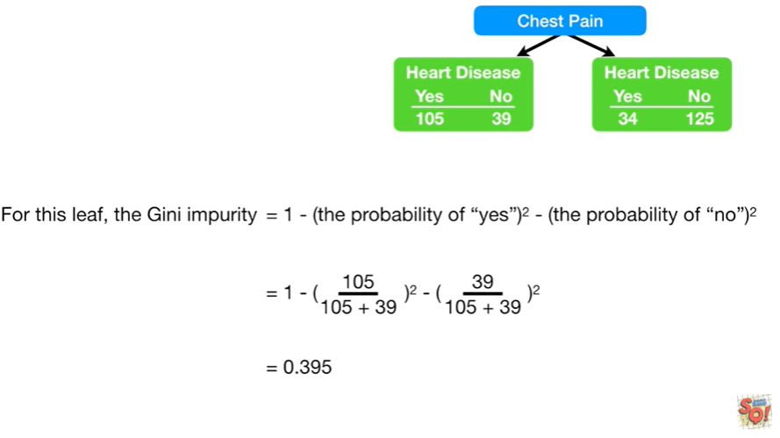

After we've done the math we get zero point three nine five.

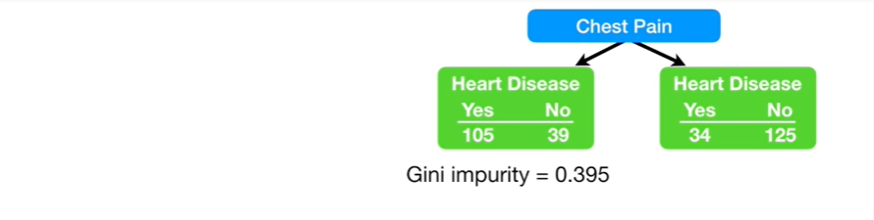

That is to say the Gini impurity for the leaf node on the Left equals zero point three nine five.

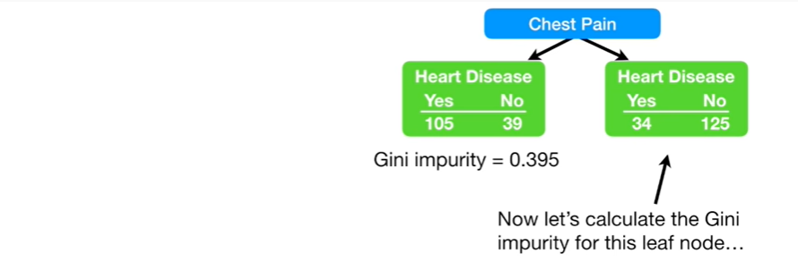

Now let's calculate the Gini impurity for this leaf node, the one on the right.

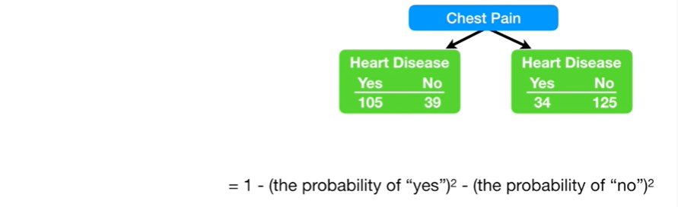

Just like before, it equals one minus the probability of yes squared minus the probability of no squared

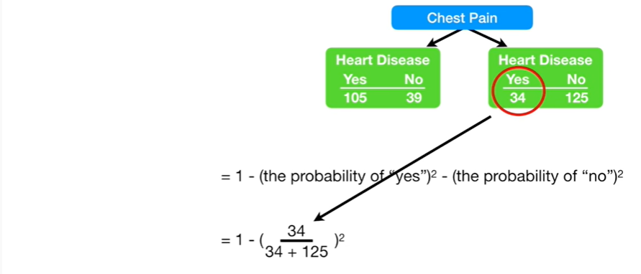

and the probability of yes is 34 divided by the total number of people in this leaf node

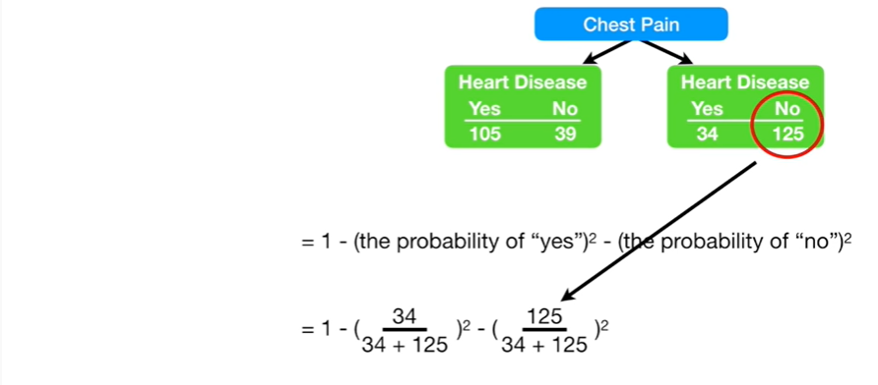

and the probability of no equals 125 divided by the total number of people in this node

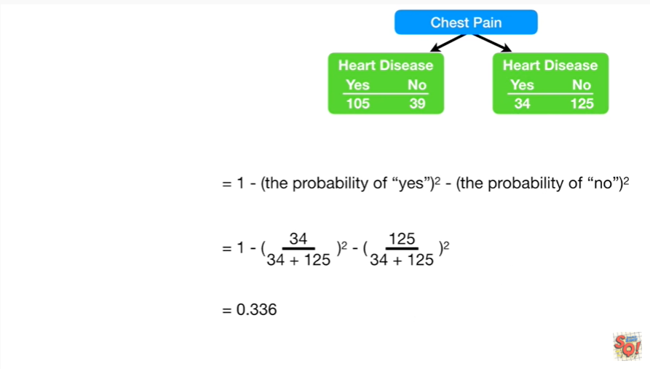

and if we do the math we get 0.336.

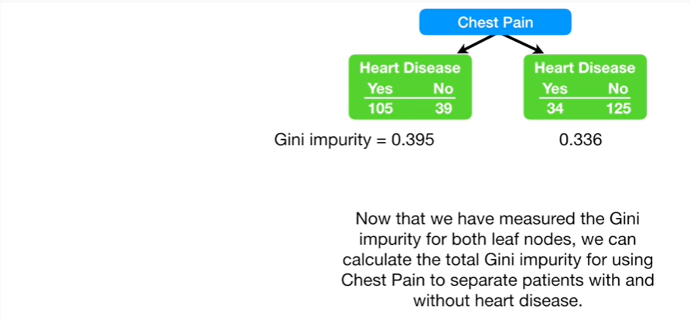

Now that we have measured the Gini impurity for both leaf nodes, we can calculate the total Gini impurity for using chest pain to separate patients with and without heart disease.

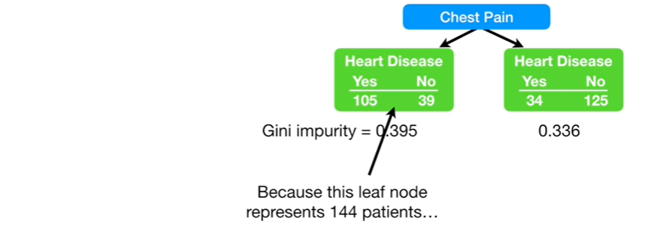

Because this leaf node represents 144 patients

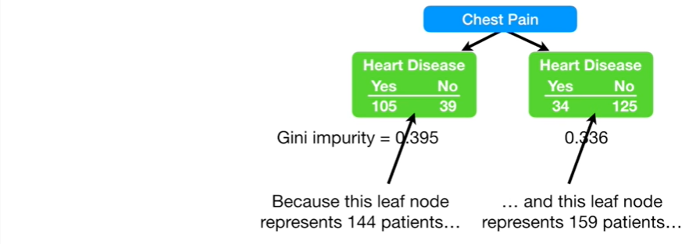

and this leaf node represents 159 patients

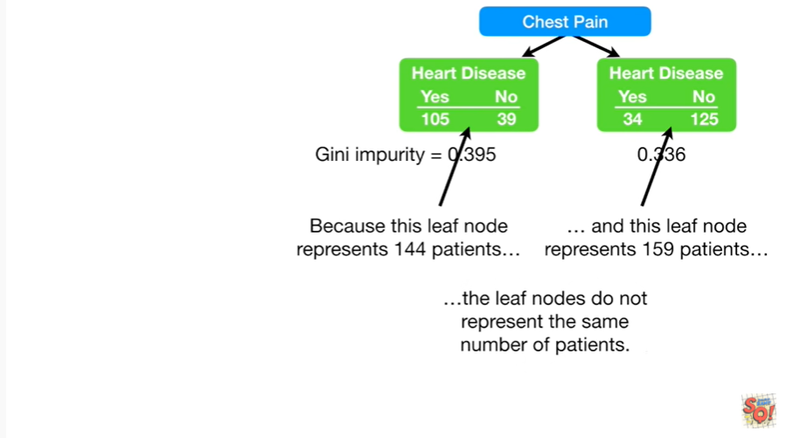

the leaf nodes do not represent the same number of patients.

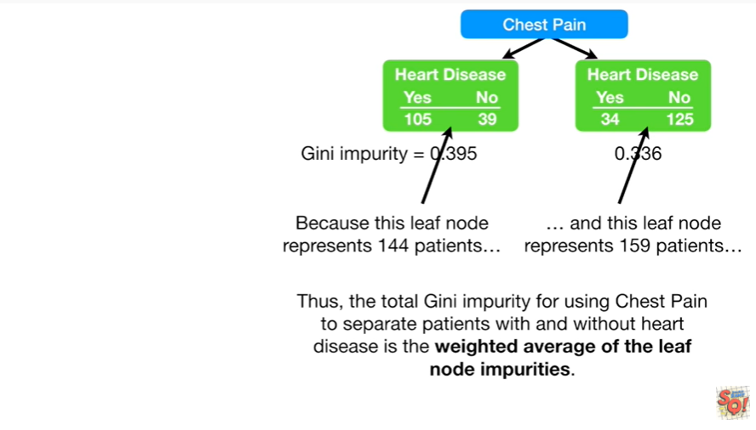

Thus the total Gini impurity for using chest pain to separate patients with and without heart disease is the weighted average of the leaf node impurities.

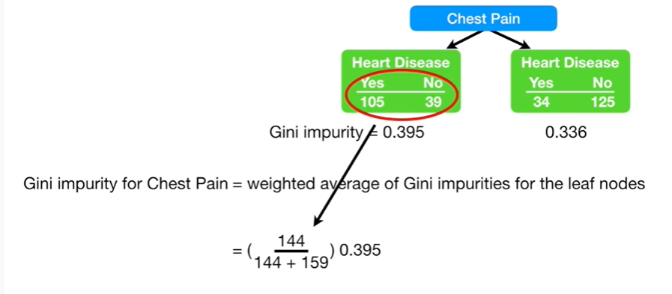

So to calculate the weighted average we take the total number of people in the left leaf node

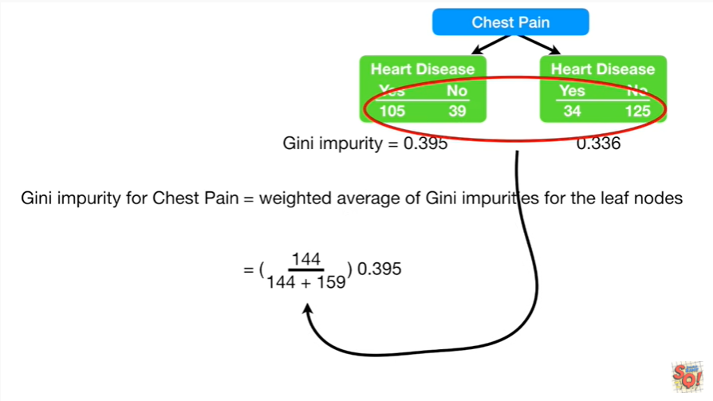 and divided by the total number of people in both leaf nodes.

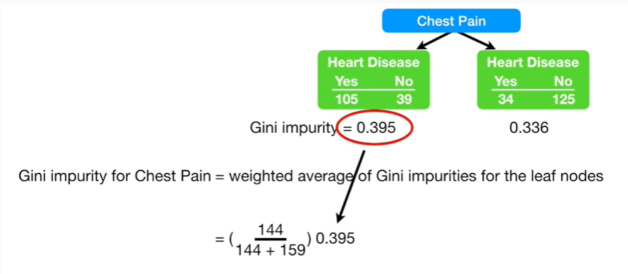

We then multiply that fraction by the Gini impurity for the left leaf node

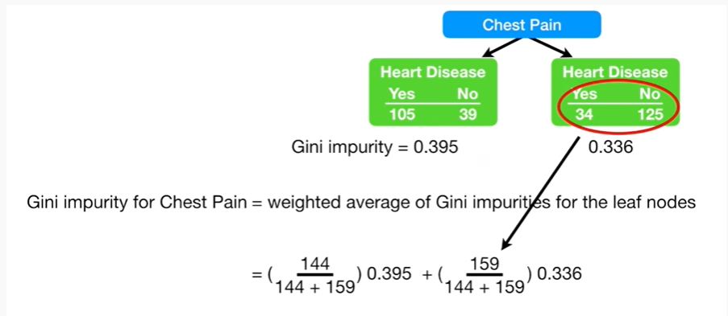

then we take the total number of people in the right leaf node

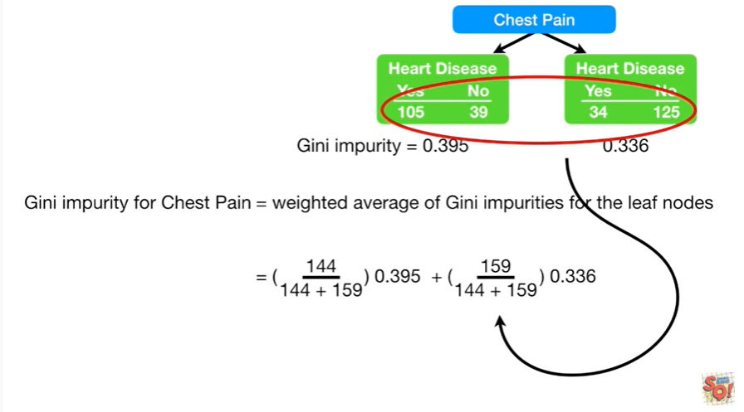

divided by the total number of people in both leaf nodes

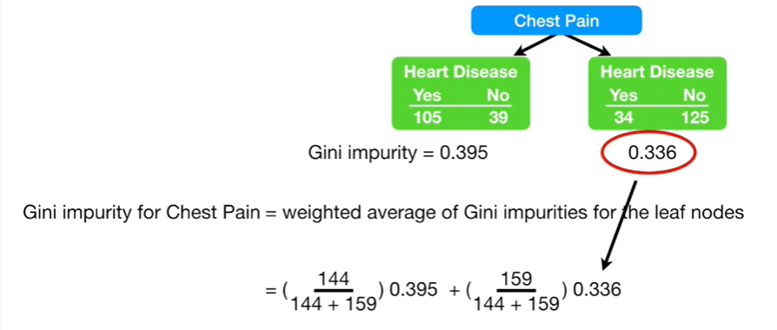

and then multiply that fraction by the Gini impurity for the right leaf node.

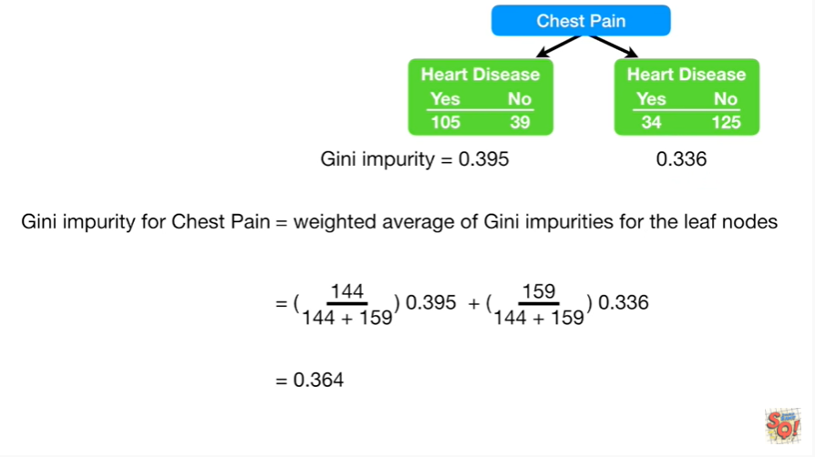

After we do the math we get 0.364.

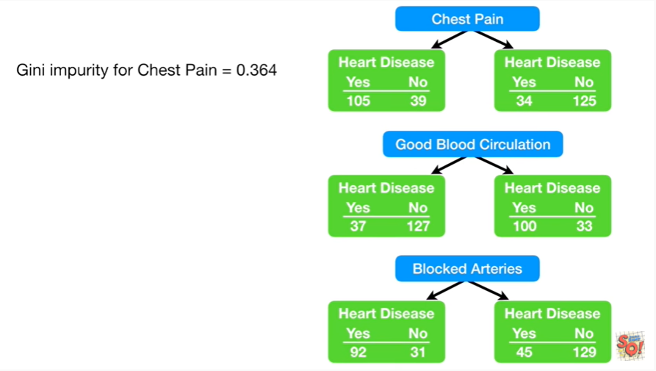

Thus the total Gini impurity for chest pain equals zero point three six four.

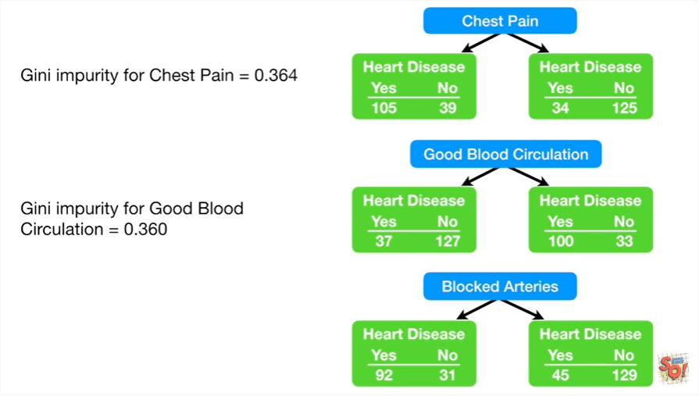

And since I'm such a nice guy I'm going to cut to the chase, and tell you that the Gini impurity for good blood circulation equals zero point three six zero.

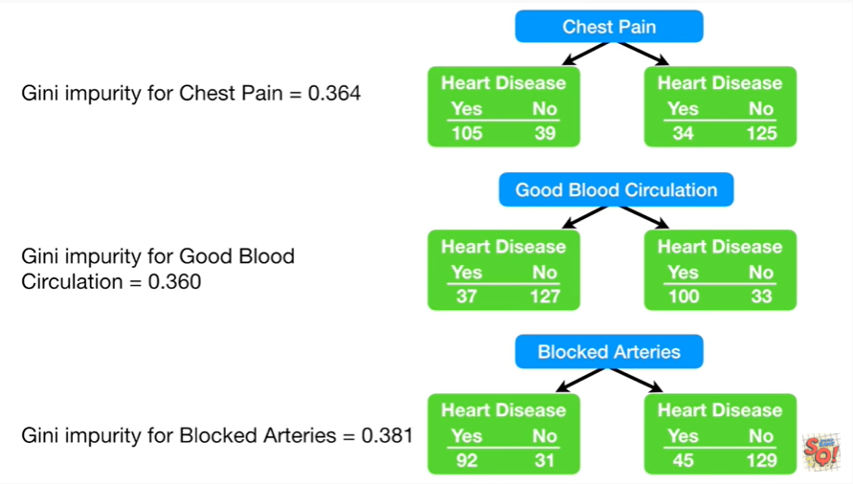

And the Gini impurity for blocked arteries equals zero point three eight one.

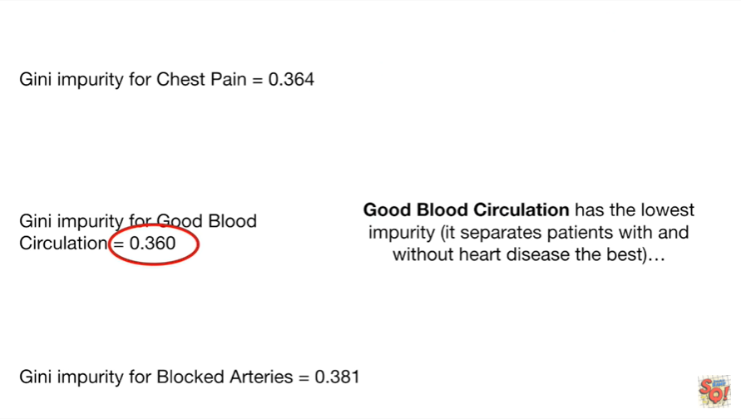

Good blood circulation has the lowest impurity (it separates patients with and without heart disease the best)

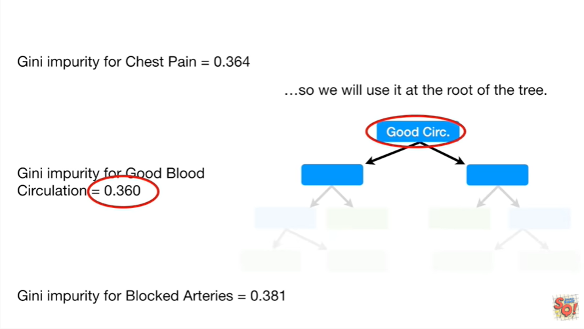

so we will use it at the root of the tree.

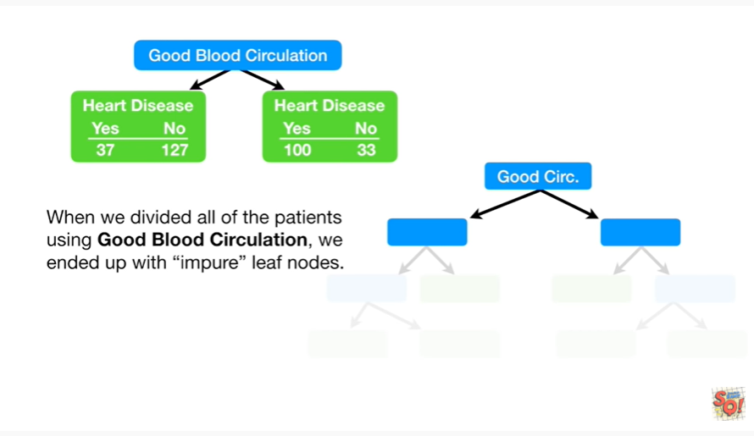

Note ;when we divided all of the patients using good blood circulation, we ended up with impure leaf nodes.

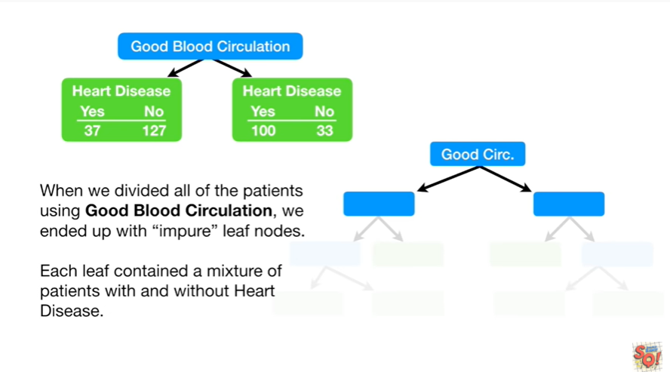

That is to say each leaf contain a mixture of patients with and without heart disease.

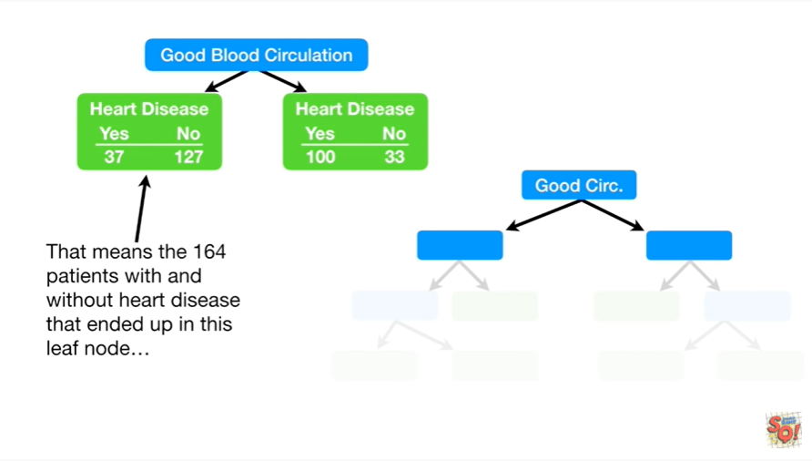

That means the 164 patients with and without heart disease that ended up in this leaf node

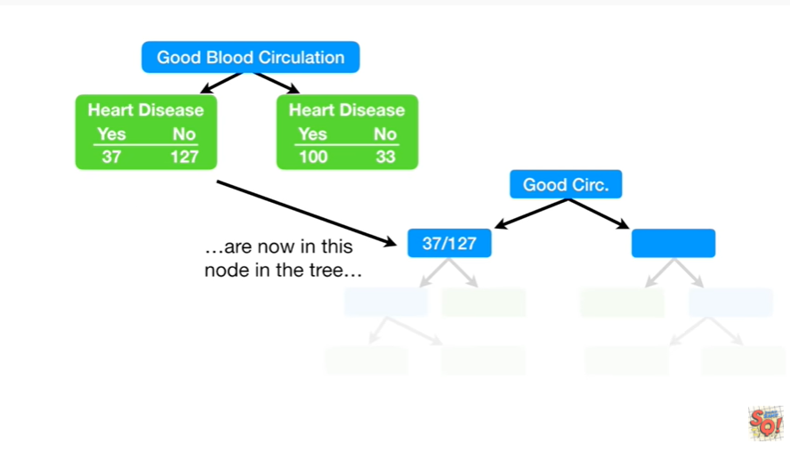

are now in this node in the tree

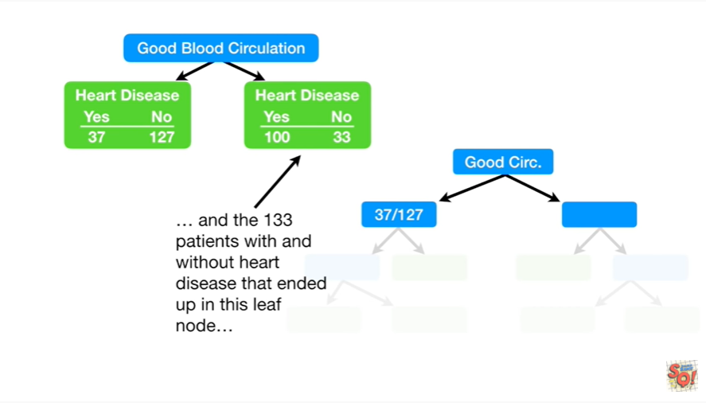

and the 133 patients with and without heart disease that ended up in this leaf node

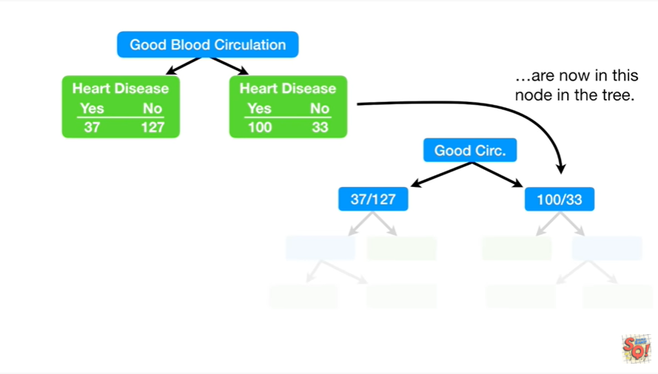

are now in this node in the tree.

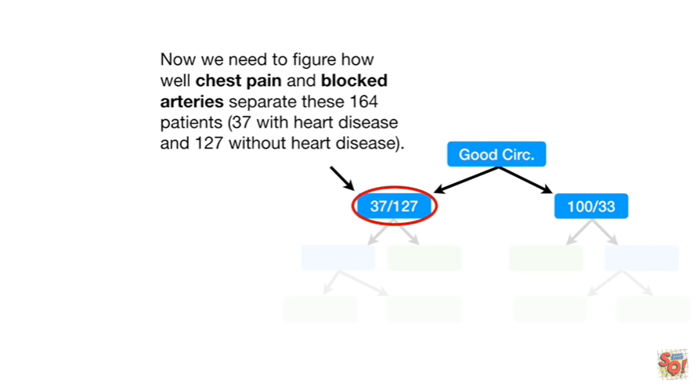

Now we need to figure out how well chest pain and blocked arteries separate these 164 patients (37 with heart disease and 127 without heart disease).

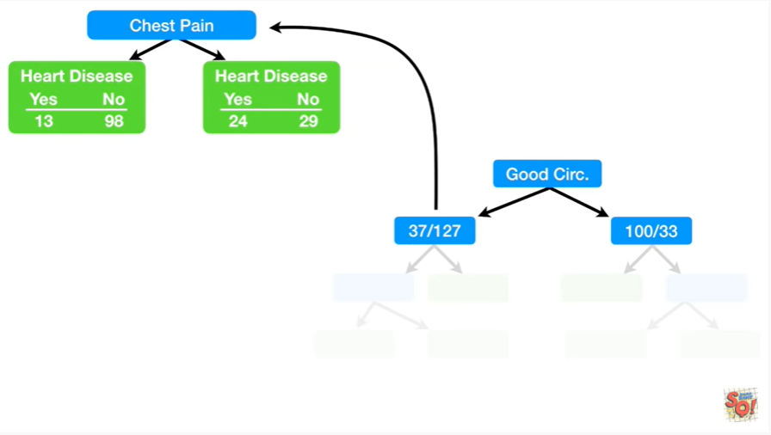

Just like we did before we separate these patients based on chest pain and then calculate the Gini impurity value.

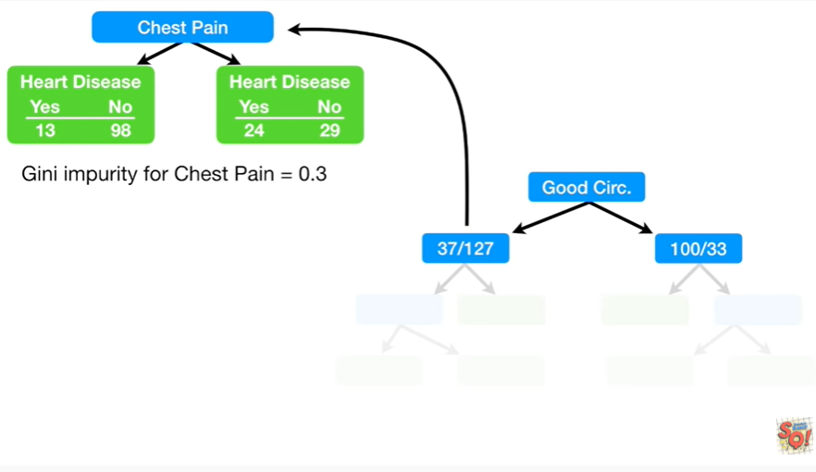

In this case it's zero point three.

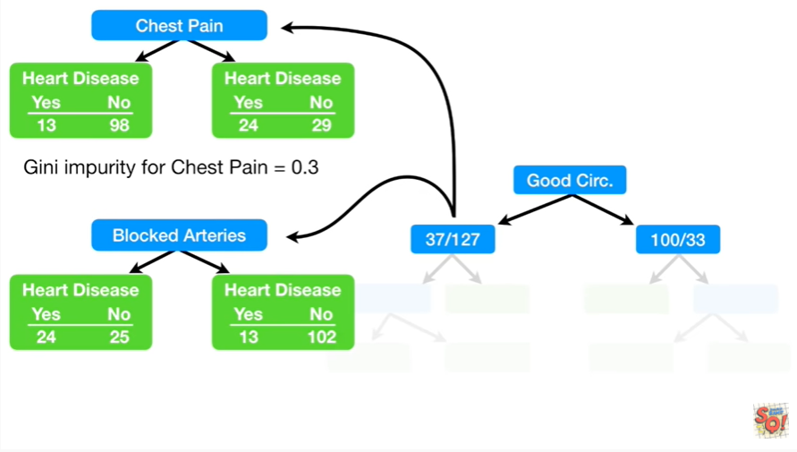

And then we do the exact same thing for blocked arteries.

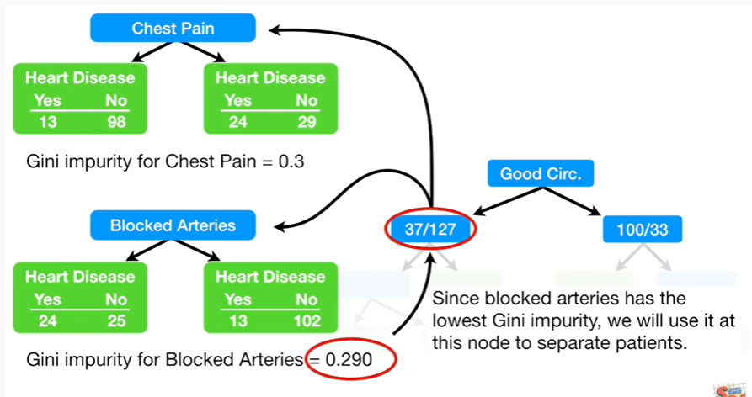

Since blocked arteries has the lowest Gini impurity we will use it at this node to separate patients.

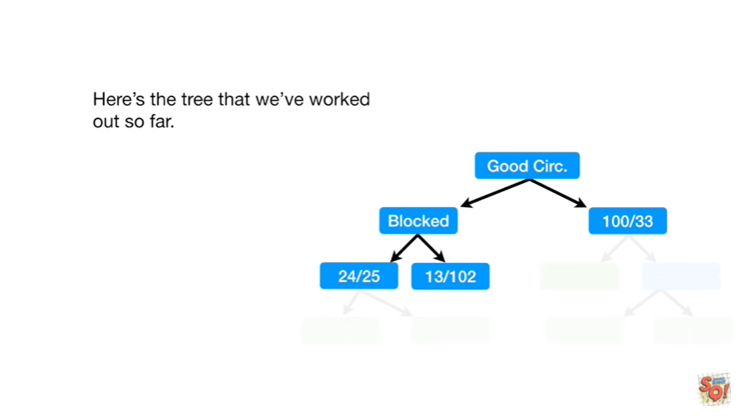

Here's the tree that we worked out so far.

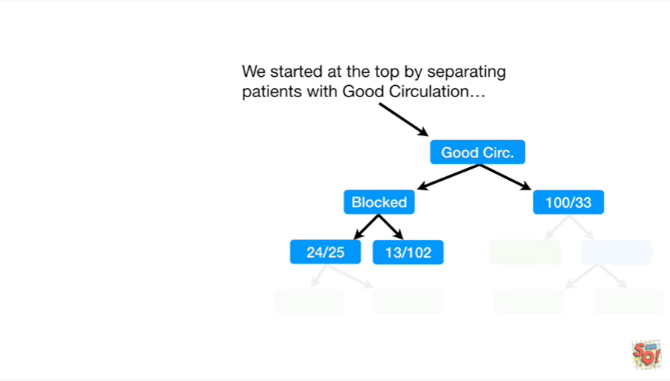

We started at the top by separating patients with good circulation

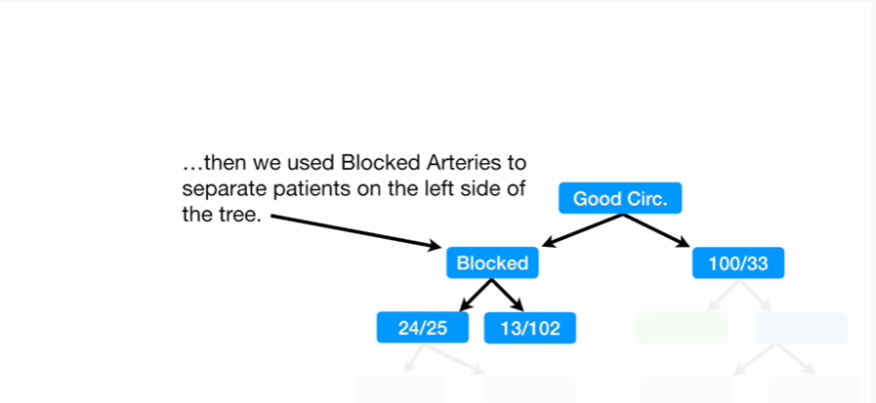

then we used blocked arteries to separate patients on the left side of the tree.

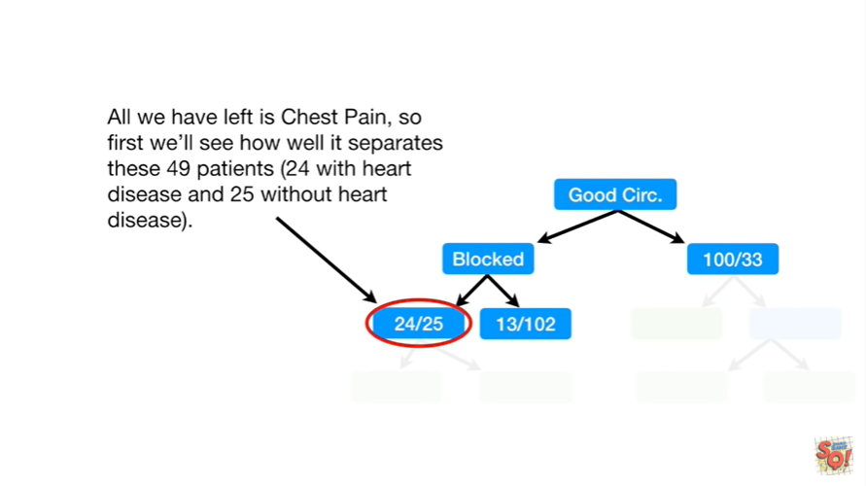

All we have left is chest pain so first we'll see how well it separates these 49 patients (24 with heart disease and 25 without heart disease).

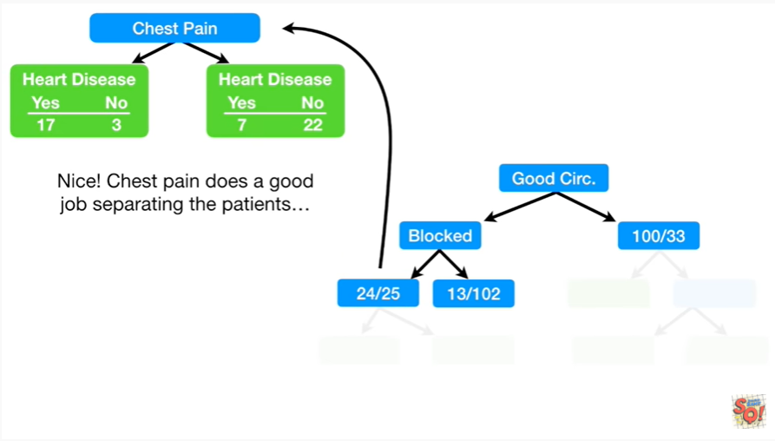

Nice !

Chest pain does a good job separating the patients.

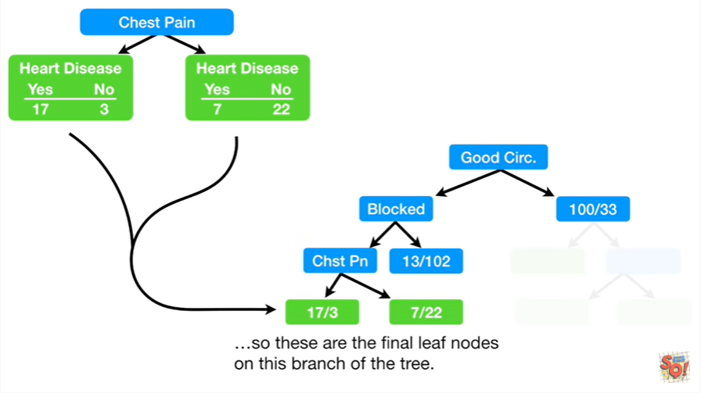

So these are the final leaf nodes on this branch of the tree.

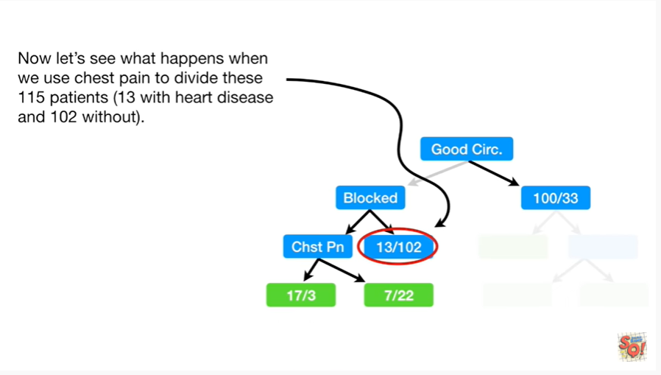

Now let's see what happens when we use chest pain to divide these 115 patients (13 with heart disease and 102 without).

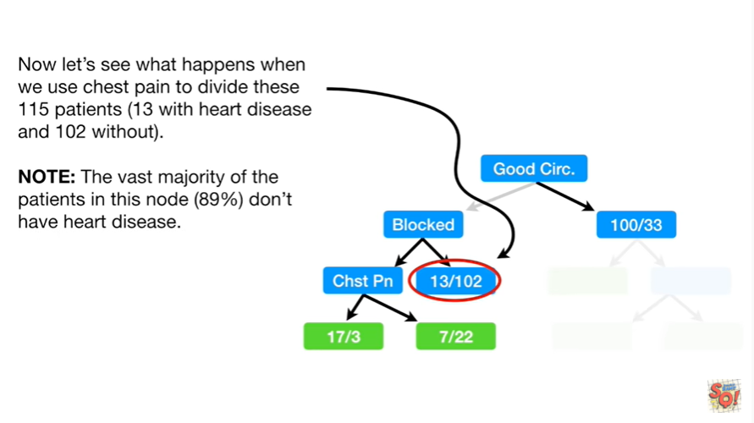

Note : the vast majority of the patients in this node (89%) don't have heart disease.

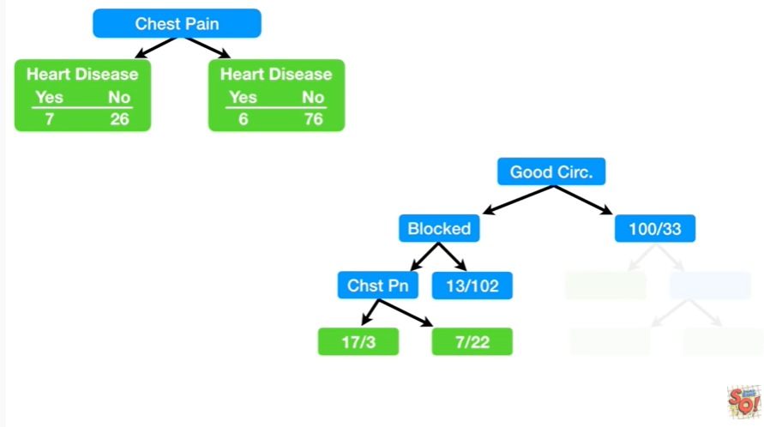

Here's how chest pain divides these patients.

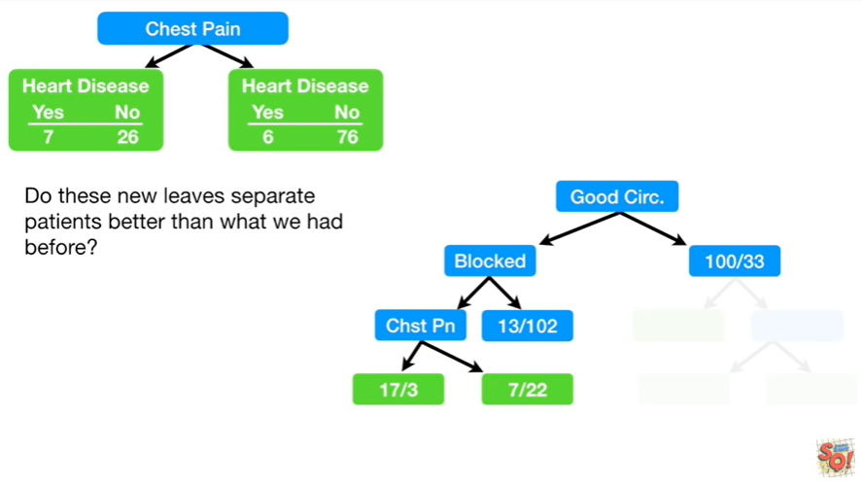

Do these new leaves separate patients better than what we had before ?

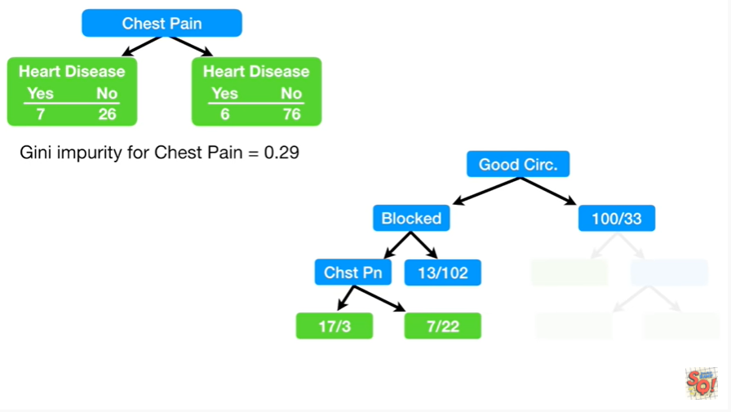

Well let's calculate the Gini impurity for it.

In this case it's zero point two nine.

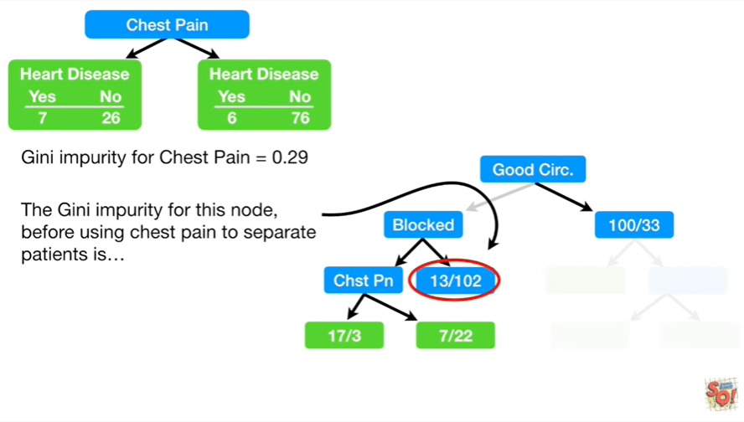

The Gini impurity for this node before using chest pain to separate patients is

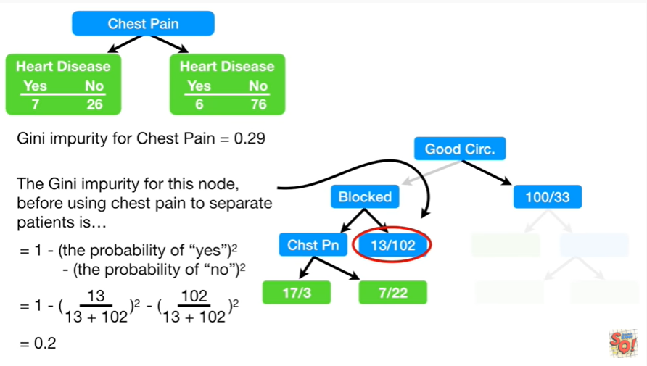

0.2.

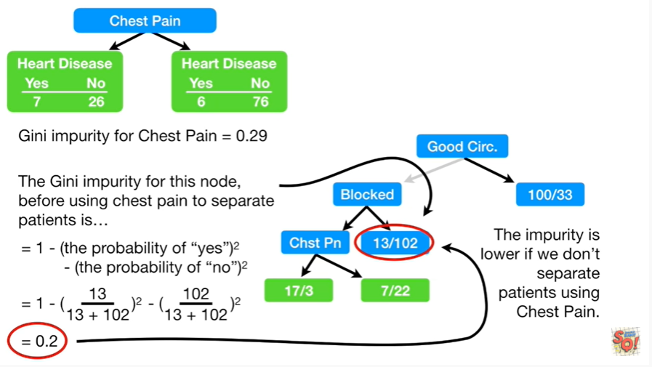

The impurity is lower if we don't separate patients using chest pain.

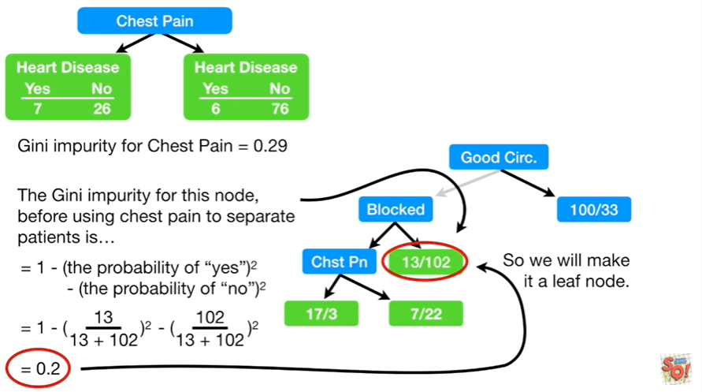

So we will make it a leaf node.

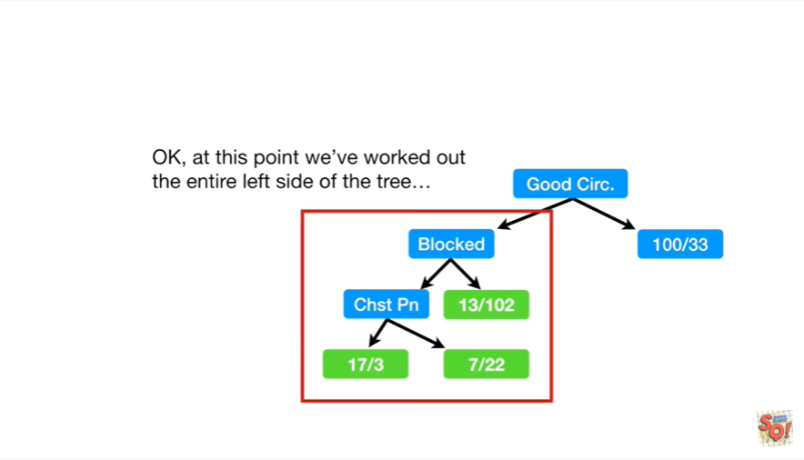

Okay, at this point we've worked out the entire left side of the tree

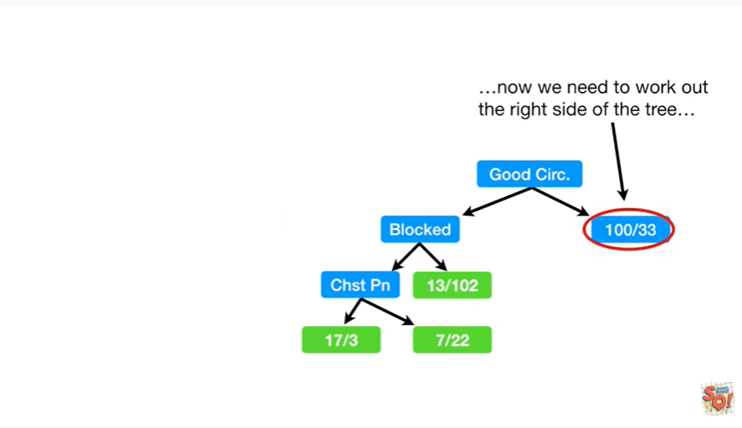

now we need to work out the right side of the tree.

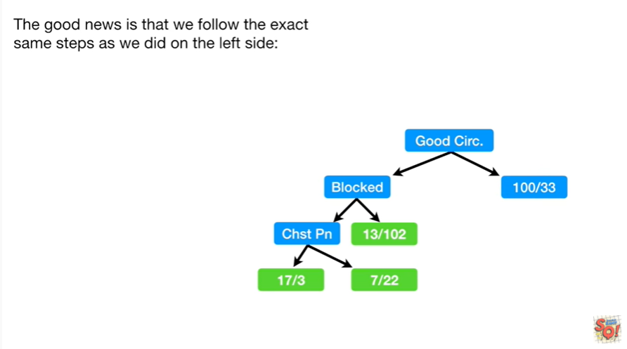

The good news is that we follow the exact same steps as we did on the left side :

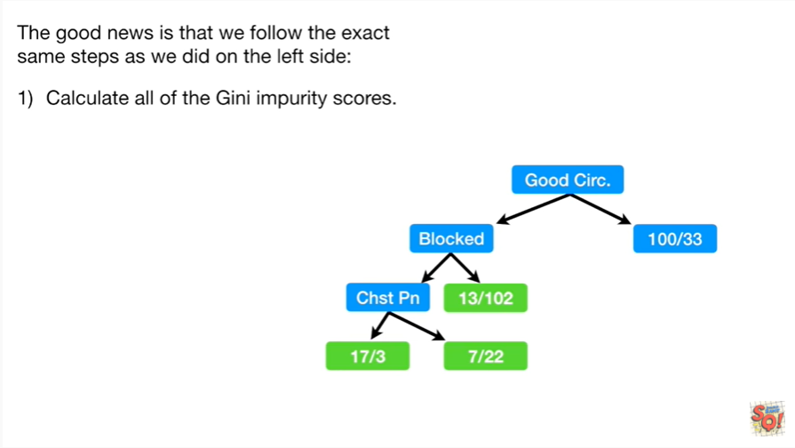

1. First we calculate all the Gini impurity scores.

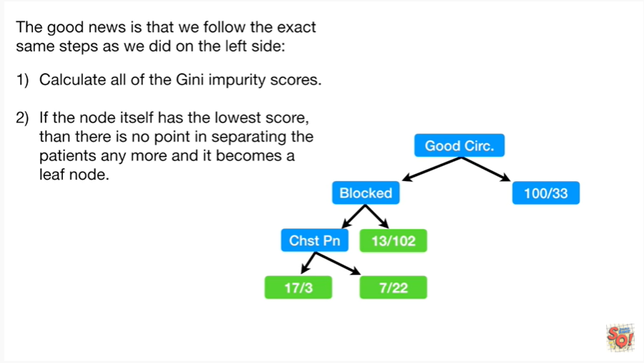

2. second if the note itself has the lowest score then there is no point in separating the patients anymore and it becomes a leaf node.

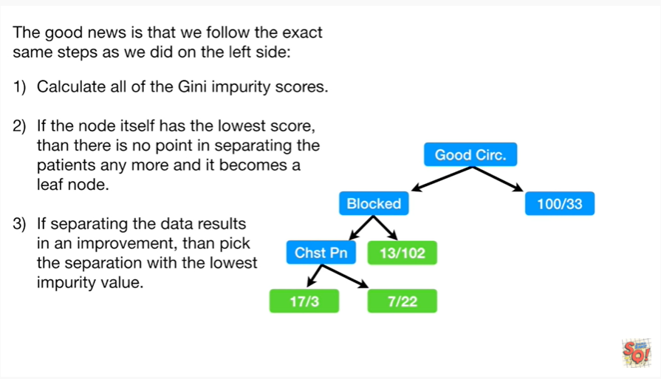

3. third if separating the data results in an improvement then pick the separation with the lowest impurity value.

Hooray !!!

We made a decision tree !!!

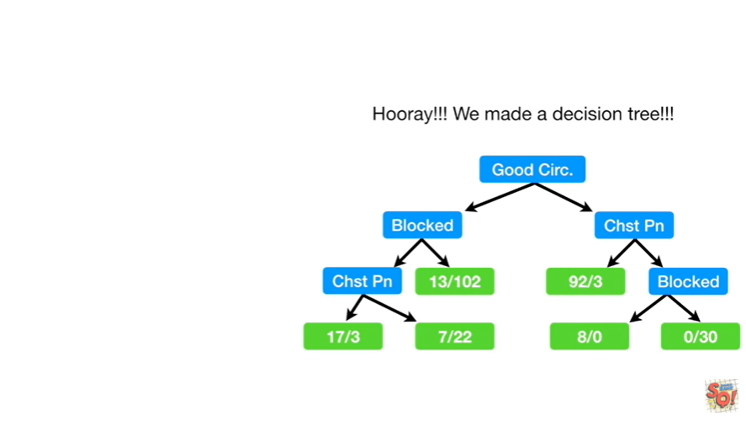

So far we've seen how to build a tree with yes/no questions at each step

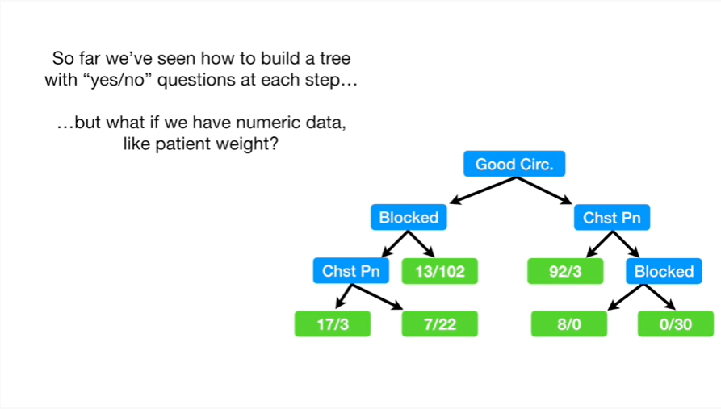

but what if we have numeric data like patient weight ?

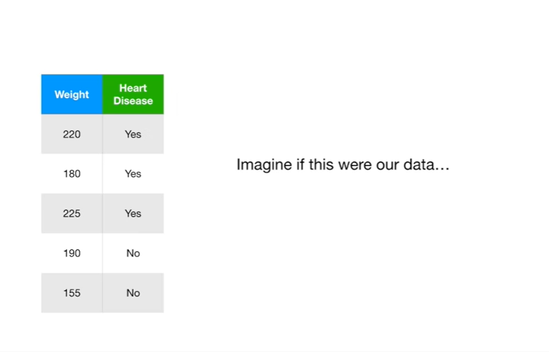

Imagine if this were our data.

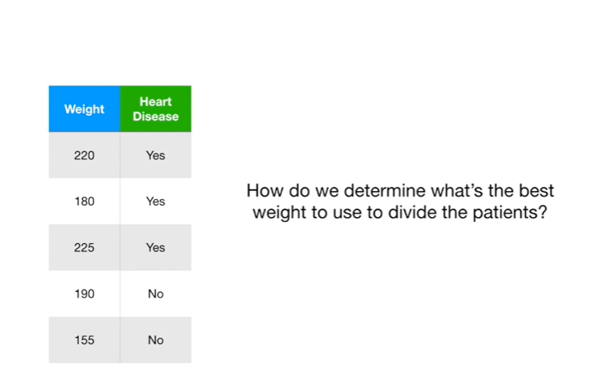

How do we determine what's the best way to use to divide the patients ?

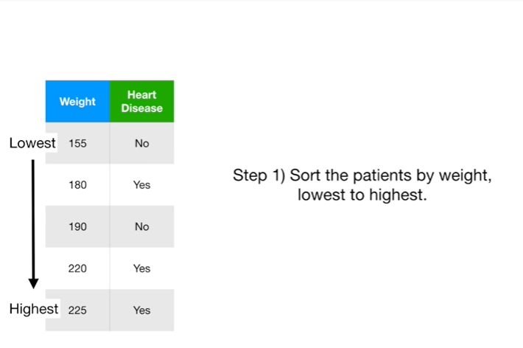

Step 1 : sort the patients by weight lowest to highest.

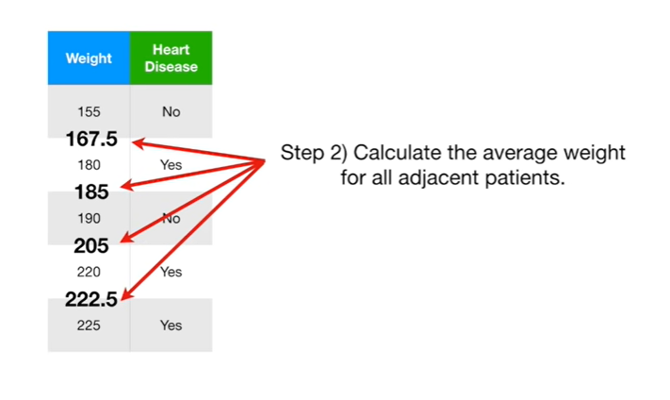

Step 2 : calculate the average weight for all adjacent patients.

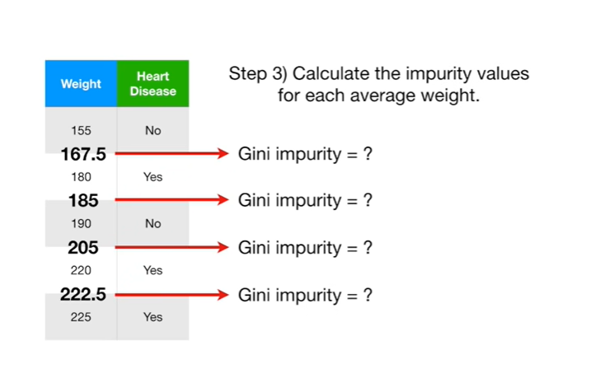

Step 3 : calculate the impurity values for each average weight.

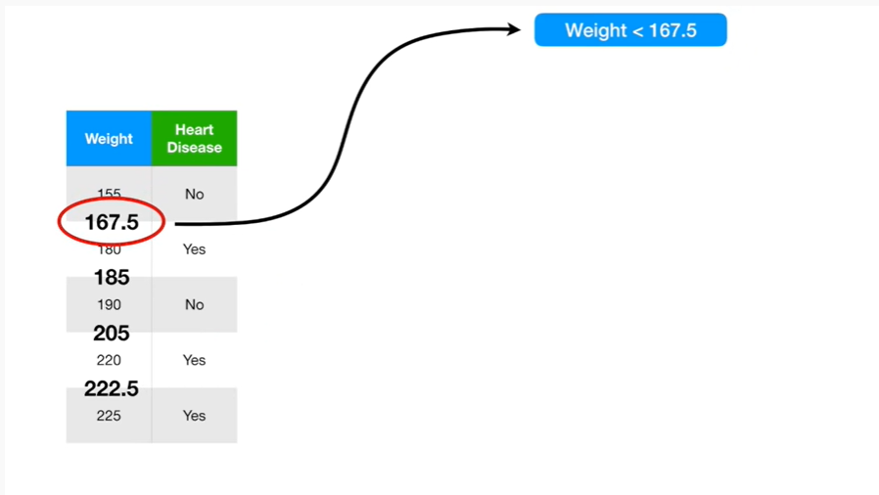

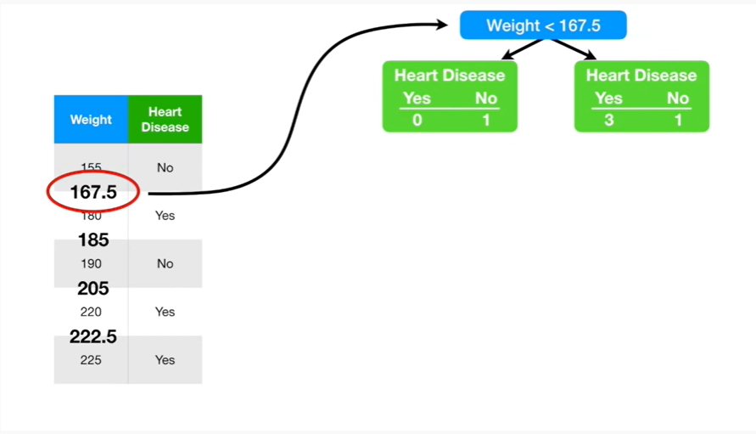

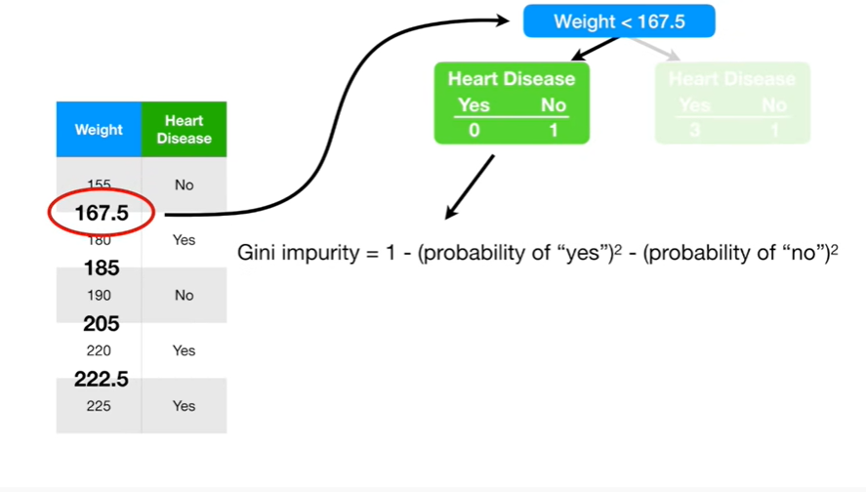

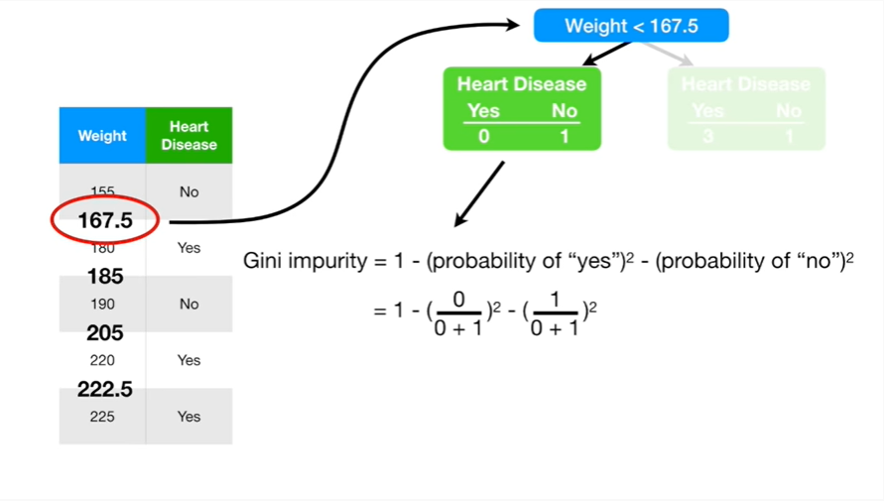

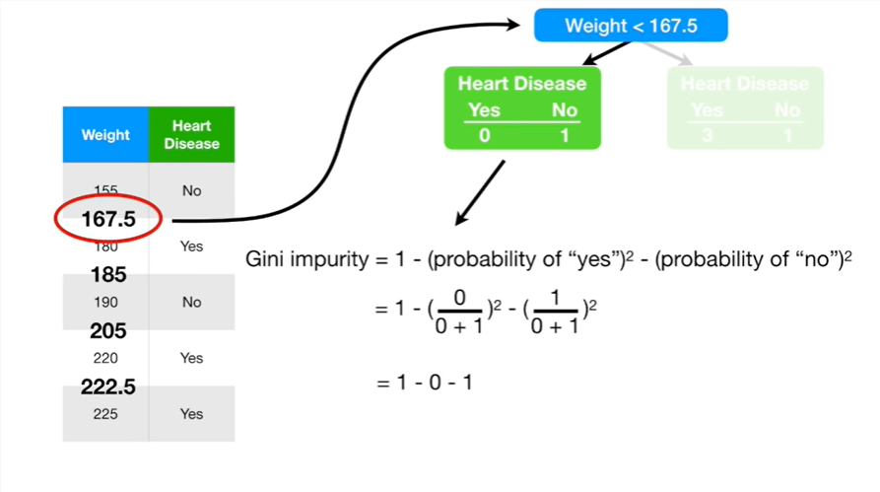

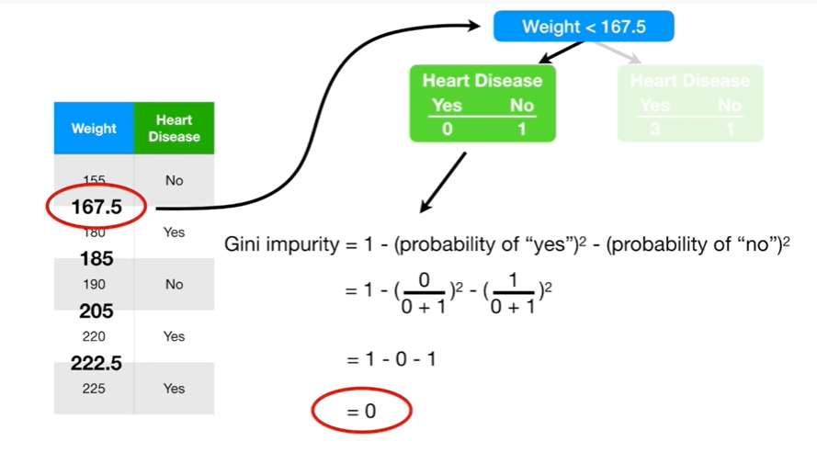

For example we can calculate the impurity value for weights less than 160 7.5

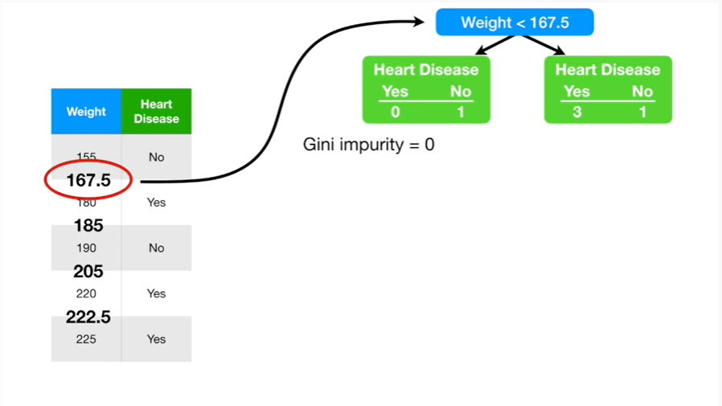

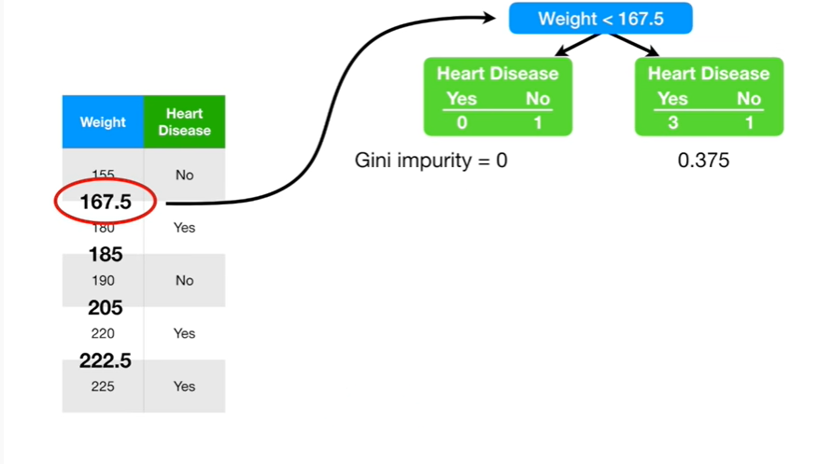

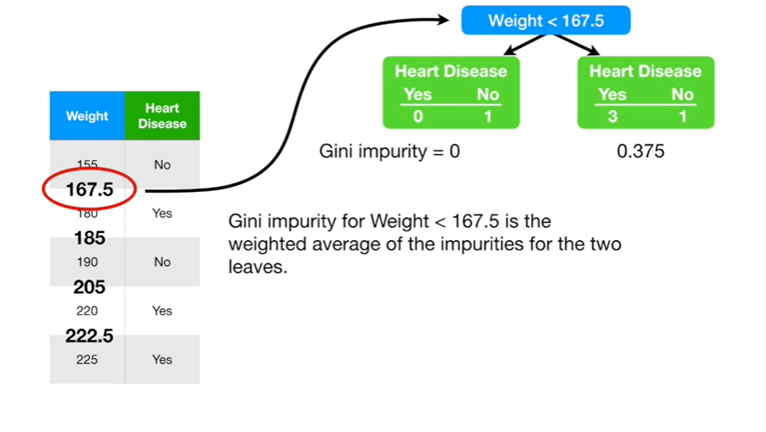

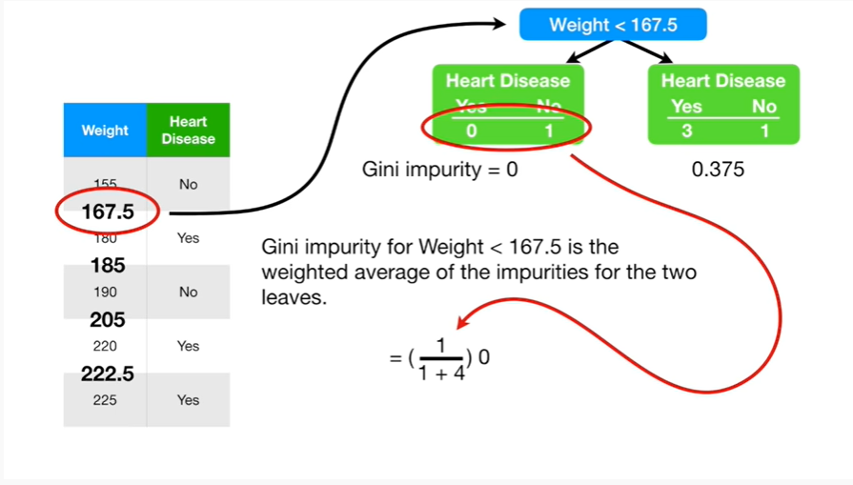

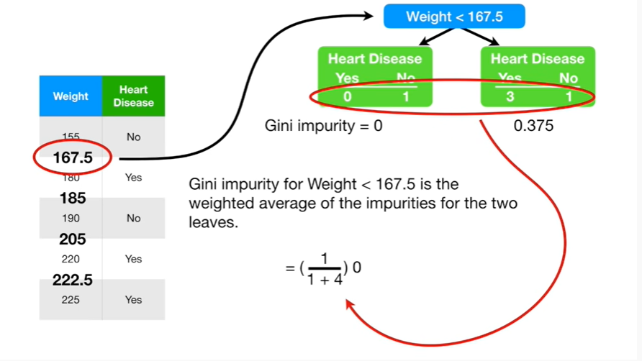

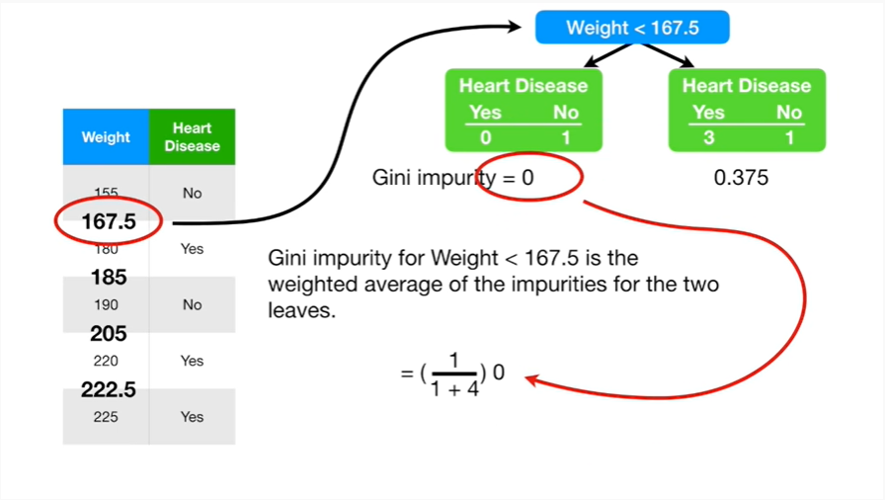

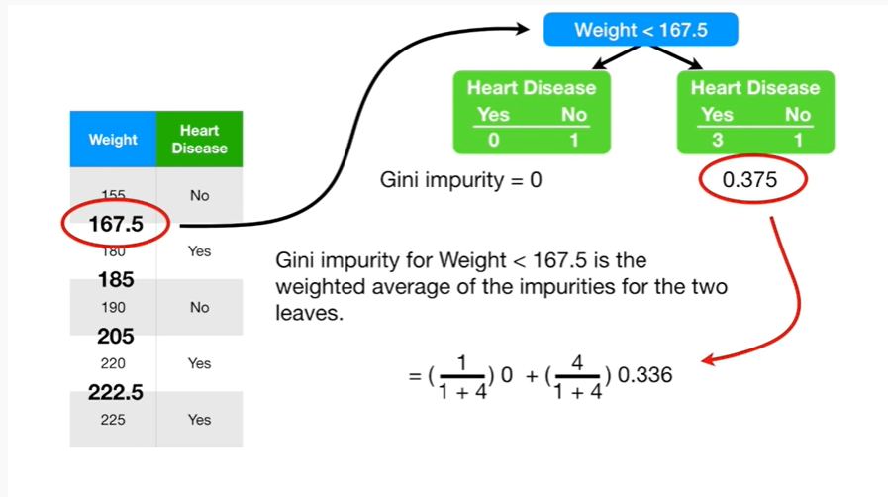

dooba dooba dooba dooba dooba dooba do dooba dooba dooba boo

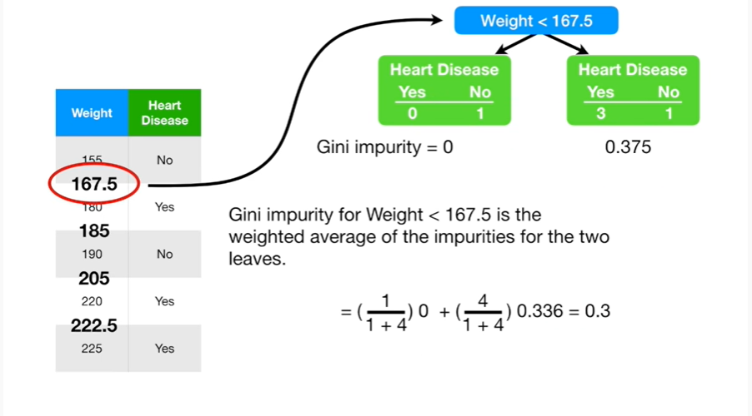

Ultimately we get 0.3 as the impurity value for this weight.

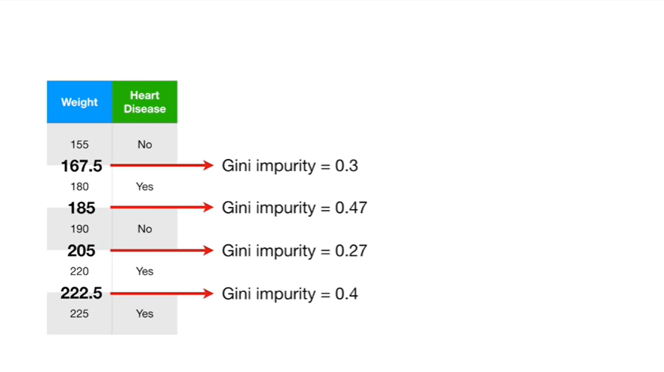

And then we calculate the impurity values for the other weights as well.

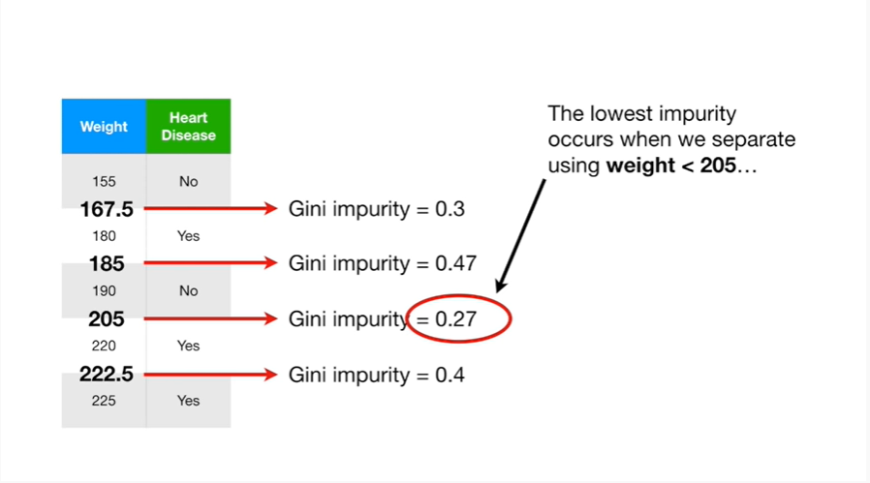

The lowest impurity occurs when we separate using weight less than 205

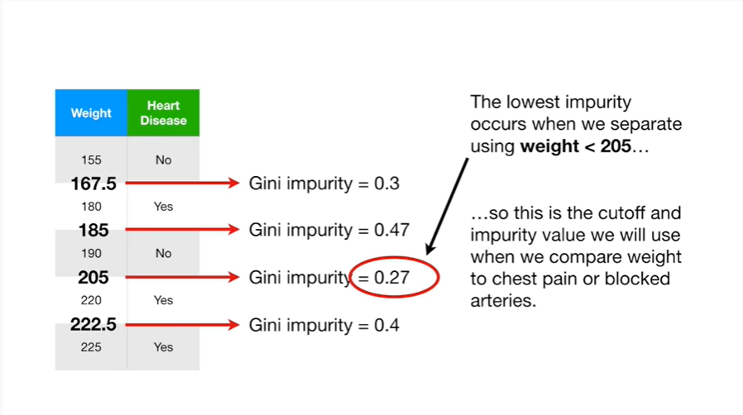

so this is the cutoff in the impurity value we will use when we compare weight to chest pain or blocked arteries.

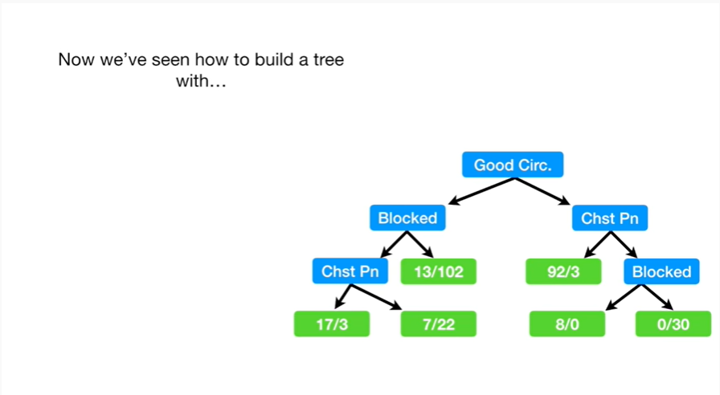

Now we've seen how to build a tree :

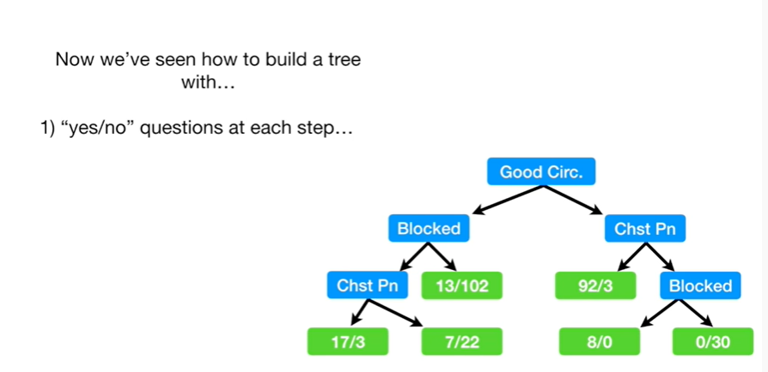

1. with yes/no questions at each step

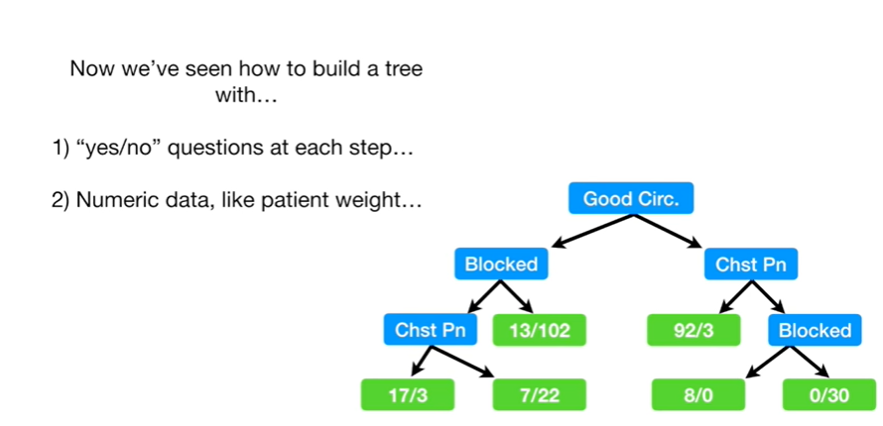

2. and numeric data, like patient weight.

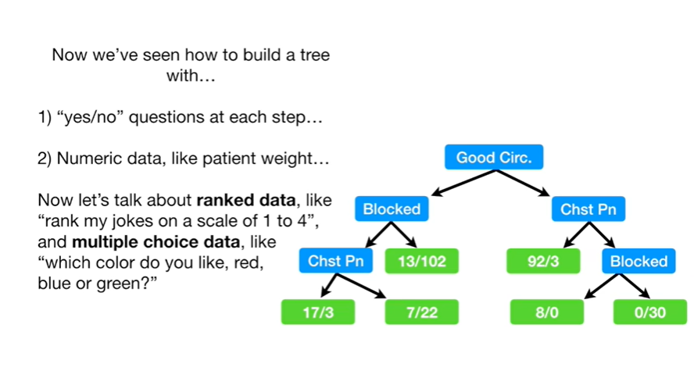

Now let's talk about ranked data, like rank my joke's on a scale of 1 to ,4 and multiple-choice data, like which color do you like, red, blue or green ?

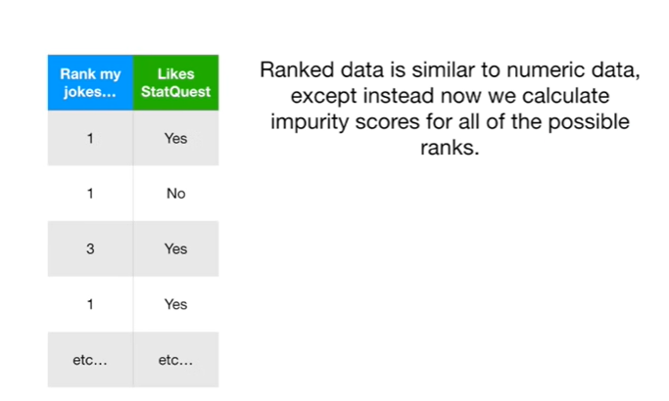

Ranked data is similar to numeric data except now we calculate impurity scores for all of the possible ranks.

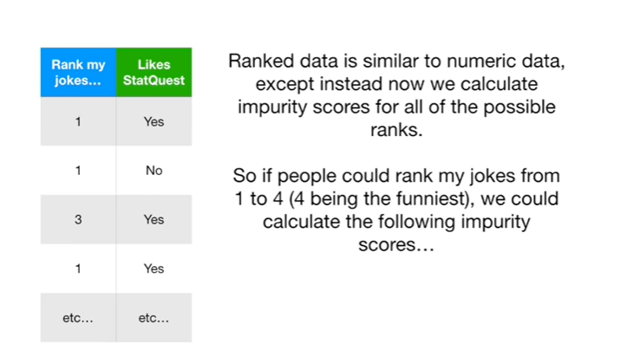

So if people could rank my jokes from one to four for being the funniest we could calculate the following impurity scores.

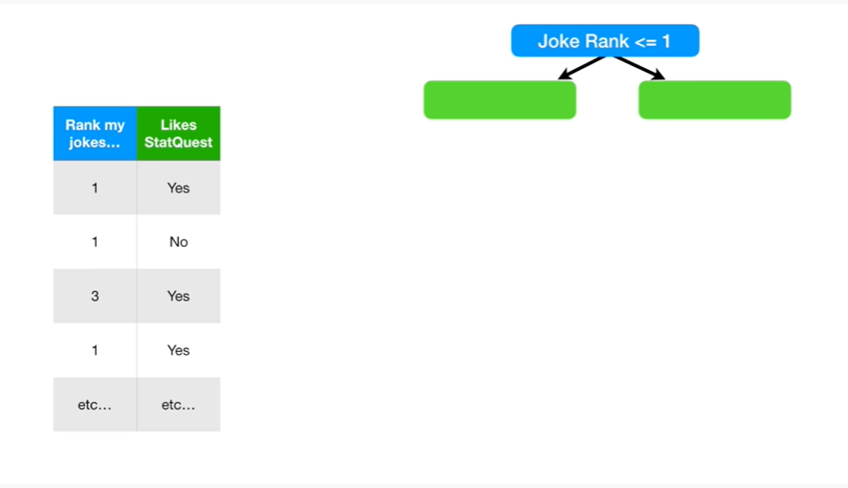

Joke rank less than or equal to one.

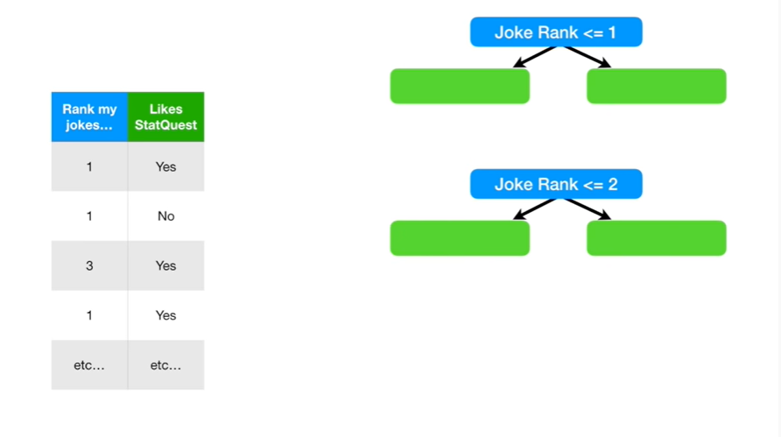

Joke rank less than or equal to two.

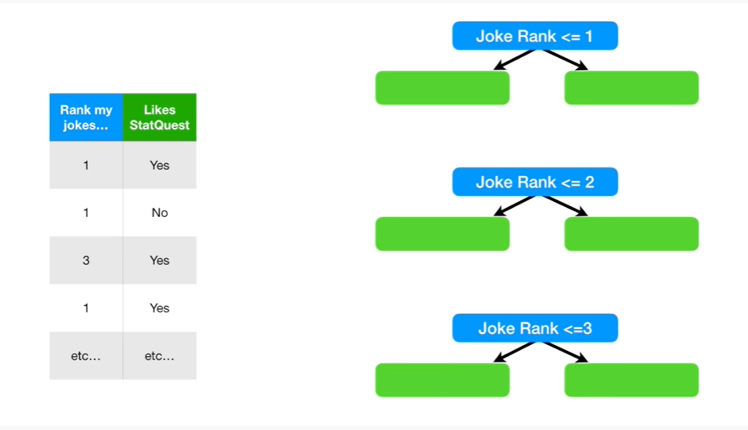

And joke rank less than or equal to three.

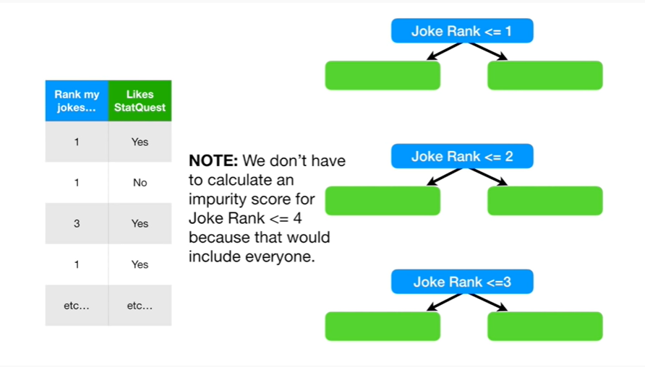

Note : we don't have to calculate an impurity score for Jill crank less than or equal to 4 because that would include everyone.

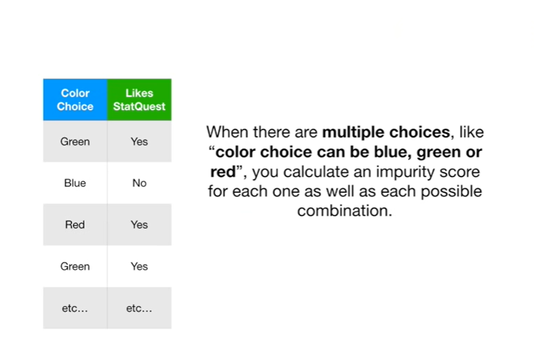

When there are multiple choices, like color choice can be blue, green or red, you calculate an impurity score for each one as well as each possible combination.

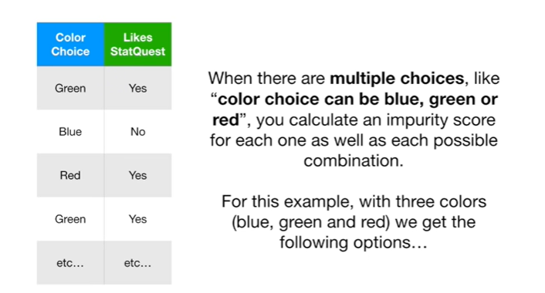

For this example with three colors blue, green and red, we get the following options :

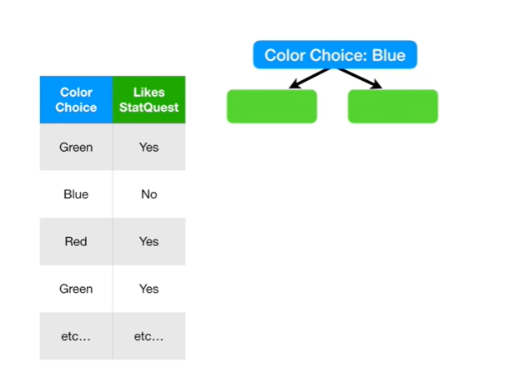

color choices blue

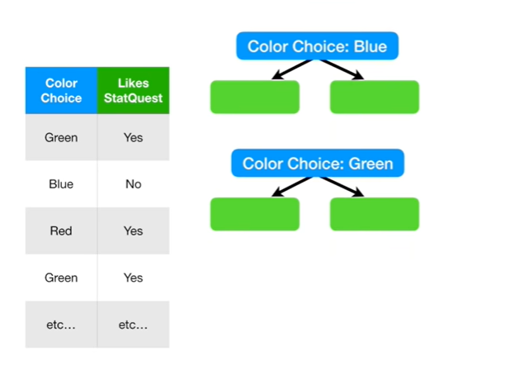

color choices green

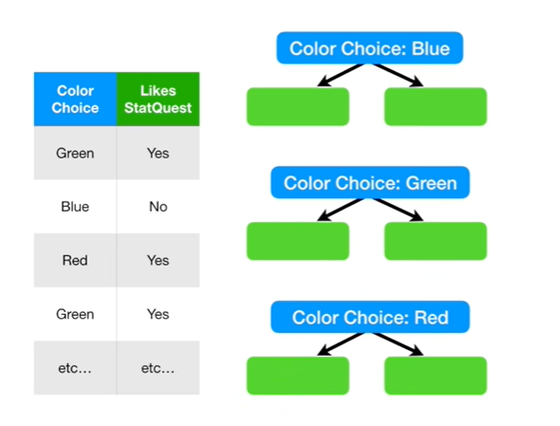

color choices red

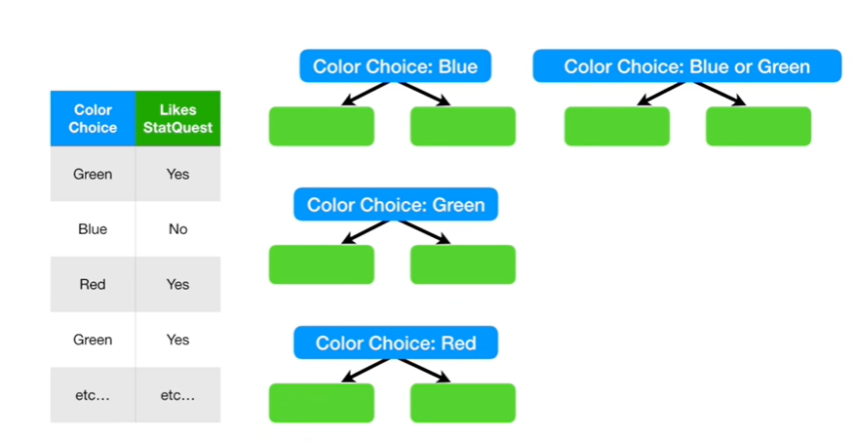

color choices blue or green

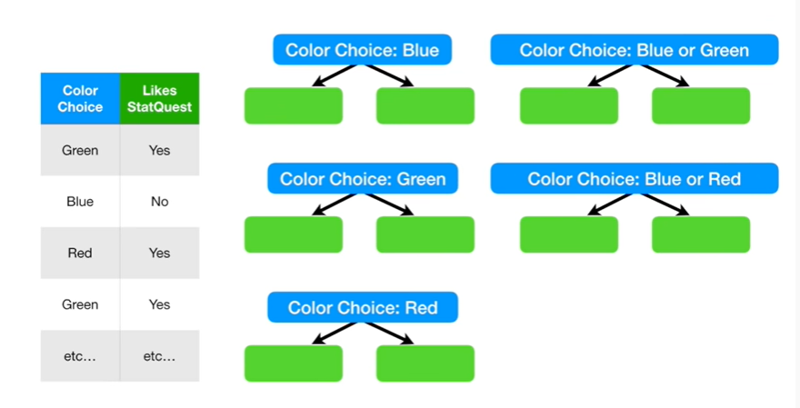

color choices blue or red

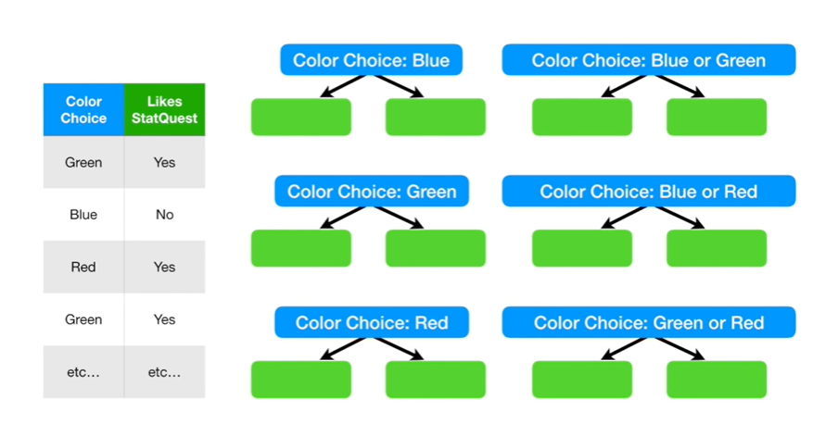

and lastly color choices green or red.

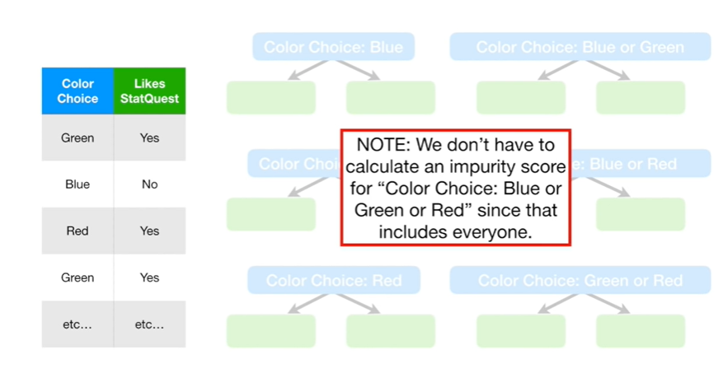

Note : we don't have to calculate an impurity score for the color choice blue green or red since that includes everyone !

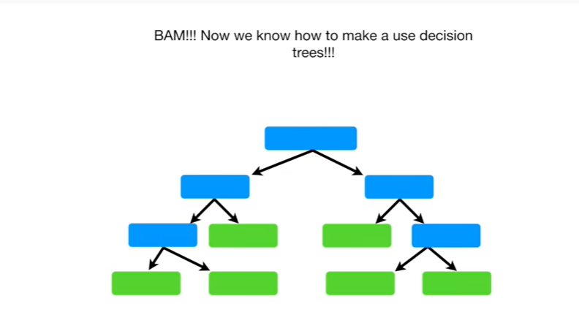

BAM !!!

Now we know how to make and use decision trees !!!